DESIGN AND IMPLEMENTATION OF A WEB-BASED PATIENT APPOINTMENT AND RECORD TRACKING SYSTEM
BY

ABDULMALIK BELLO
COS/8546/2021

A PROJECT SUBMITTED TO THE DEPARTMENT OF COMPUTER SCIENCE, COLLEGE OF SCIENCE, FEDERAL UNIVERSITY OF PETROLEUM RESOURCES, EFFURUN, DELTA STATE

IN PARTIAL FULFILMENT FOR THE AWARD OF A BACHELOR OF SCIENCE (BSc) DEGREE IN COMPUTER SCIENCE

Supervised by
Dr. NWOZOR BLESSING

MARCH 2026

Abstract
Patient appointment experience is an important aspect of delivering effective healthcare services, particularly in developing nations where outdated record-keeping systems compromise care quality. This study introduces a Web-based Patient Appointment Scheduling and Record Tracking System designed to address inefficiencies in traditional paper-based records, which often lead to delays, misdiagnoses, and poor service delivery. Leveraging advancements in Information and Communication Technology (ICT), the system enables real-time access to medical records, streamlines administrative processes, and improves both patient and provider outcomes.
The system aims to reduce appointment booking time, minimize data loss, enhance data security, and empower patients by providing them with secure access to their health information. Specific objectives include real-time access to records, reduction of waiting time, avoidance of duplication, secure data protection, and active patient engagement.
The system was developed using Rapid Application Development (RAD), a methodology chosen for its iterative approach and emphasis on delivering results quickly without compromising quality. The backend was implemented using secure web technologies, enabling centralized storage and real-time updates. Empirical analysis reveals significant improvements in key performance metrics compared to the existing system. User experience increased by 50%, access time improved by 80%, and appointment booking time reduced by 60%. Data security also rose by 50%. The system demonstrated high statistical significance (p < 0.05) in all evaluated areas.
This web-based application offers a comprehensive solution for managing healthcare records. It reduces manual workload, enhances communication, and improves service delivery. The system’s design offers a scalable, secure, and efficient alternative to outdated healthcare data practices.

CHAPTER ONE
INTRODUCTION
  - Background of the Study
Over the past decade, advancements in Information and Communication Technologies (ICT) have significantly improved various services, particularly in the healthcare sector (Zaid, 2013). Leveraging these technological developments, we implemented an electronic medical database in Iraq to enhance healthcare management and delivery.
Medical care services generally fall into three categories: in-patient (hospitals), out-patient (clinics), and emergency care. In Iraq, in-patient hospitals are further classified into specialized hospitals, such as gastrointestinal (GIT) centres, cardiac centres, and cancer centres, and general hospitals. While specialized hospitals are a relatively new addition to Iraq’s healthcare system, general hospitals have long been in place. Given the critical role hospitals play in healthcare infrastructure, we focused on improving services within them.
To achieve this, we developed and deployed the Electronic Patient Record Management System (EPRMS), the first of its kind in Iraq’s general hospitals. EPRMS functions as both a database and a workflow system, offering valuable support in hospital management, patient care, research, and record-keeping. For administrators, the system enables performance monitoring of physicians and facilitates statistical reporting. Physicians can quickly access detailed patient histories, reducing consultation time and improving diagnosis. Additionally, researchers benefit from advanced search capabilities for medical studies. Compared to traditional paper-based records, EPRMS ensures greater reliability, security, and efficiency in archiving and managing patient information. A nation's economic growth and stability are deeply intertwined with its people's health and well-being. A thriving society is essential for building a strong and economically sustainable nation, regardless of racial or geographical differences. Health and wellness serve as fundamental pillars for sustainable socioeconomic progress, cultural harmony, and peaceful coexistence, playing a pivotal role in both individual and societal development.
Health is one of the most vital aspects of human existence, and access to quality medical care is essential for overall well-being. Delivering effective healthcare relies on well-structured and properly maintained health information systems. Since healthcare is a service provided by people for people, its impact spans an individual's entire life, from birth until death (Winter et al., 2023).
According to Raji (2018), the World Health Organization (WHO) defines health as more than just the absence of illness, disease, or infirmity. It is a holistic state of well-being encompassing physical, mental, and social health. Across the globe, whether in developed, developing, or underdeveloped nations public health and well-being are recognized as fundamental to socioeconomic progress and poverty alleviation (Thiede, 2015).
A well-functioning healthcare system depends on the ability of healthcare providers to efficiently manage medical information, ensuring that it remains accessible, available, and accurate for practitioners delivering patient care. In any organization, effective information management is crucial for maintaining and enhancing operations, but in healthcare, it can sometimes mean the difference between life and death.
Healthcare institutions and hospital administrators are increasingly focused on the challenges of maintaining precise patient records and tracking medical activities. Given the widely accepted notion that "health is wealth," ensuring accurate and well-organized health information remains a top priority (Shimishi & Mupala, 2019). This system not only simplifies administrative tasks but also places greater control in the hands of patients by providing secure and seamless access to their medical history, prescriptions, diagnostic reports, and appointment schedules. By enabling patients to retrieve their health records at any time, the system fosters transparency and strengthens doctor-patient communication, ensuring that individuals are more actively involved in their healthcare decisions. When patients have better access to their medical information, they can make more informed choices about treatments, follow-ups, and lifestyle adjustments, ultimately leading to improved health outcomes.
Beyond patient empowerment, integrating technology into healthcare significantly reduces the risks associated with misplaced, outdated, or inaccurate records. Traditional paper-based systems are prone to human errors, physical damage, and loss, whereas digital record-keeping ensures data integrity, encryption, and controlled access, enhancing both efficiency and security. Healthcare providers can retrieve patient information instantly, allowing for quicker and more precise diagnoses while minimizing redundancy in tests and procedures.
Additionally, an online patient record-tracking system optimizes healthcare workflows by reducing waiting times, streamlining appointment scheduling, and improving communication between departments. By eliminating unnecessary delays and administrative bottlenecks, healthcare professionals can focus more on patient care. This paper explores how such systems transform patient experiences, improve operational efficiency, and contribute to a more responsive and data-driven healthcare environment.

  - Statement of the Problem
Ineffective record-keeping practices are a major cause of delays, mistakes, and unsatisfactory patient experiences in many healthcare facilities. It can be difficult to retrieve patient histories, treatment plans, and prescriptions from traditional paper-based medical records because they are prone to being lost, damaged, and inaccessible. Long wait times, incorrect diagnoses, unnecessary medical testing, and subpar patient care are frequently the outcomes of these inefficiencies. Also, disjointed record management systems make it more difficult for medical professionals to communicate effectively, which compromises the standard and continuity of care. A medical record management system that is effective, safe, and user-friendly is required in light of the increasing need for patient-centered healthcare. Many clinics and hospitals continue to use antiquated techniques that delay important medical decisions by not allowing real-time access to patient data. Likewise, patient data is susceptible to loss or unauthorised access due to the absence of a centralised record-tracking system. Offering a digital platform for real-time patient data access, storage, and updating an online patient record-tracking system solves these problems. By decreasing administrative inefficiencies, enhancing healthcare delivery, and guaranteeing data security, this study looks at how putting such a system into place improves patient experiences and promotes smooth communication between patients and healthcare professionals.
  - Aim and Objectives of the study
The aim of the dissertation is to build “Design and Implementation of Patients Appointment and Record Tracking System” that will enhance patients experience and medical practitioners.
Specific Objectives are:
- Ensure real-time access to accurate and up-to-date medical records for both healthcare providers and patients, reducing delays in diagnosis and treatment.
- Minimize waiting times and administrative bottlenecks by streamlining record management, appointment scheduling, and information retrieval.
- Provide a centralized system that helps healthcare providers avoid duplication of medical tests and ensures accuracy in patient history, prescriptions, and treatment plans.
- Implement encryption and access control measures to protect sensitive patient information from unauthorized access, loss, or breaches.
- Empower patients by granting them secure access to their medical records, enabling better tracking of their health conditions and encouraging active participation in their healthcare decisions.
1.4 Significance of the Study
The significance of the web patient’s health record management system over the paper-based record system includes;
- Improved access to patients medical record,
- Improve the quality of care as the implementation of patients health record information management system can reduce the suffering faced by patients due to error as their medical records can be accessed and updated in real time,
- Electronic record provides access to unprecedented amounts of clinical data for research that can accelerate the level of knowledge of effective medical practices,
- The systems have the advantages of being able to connect to many electronic medical record systems

  - Scope of the Study
The scope of this research work is limited to web application technology for patients’ health record and information management system including health history, treatments, bills and payments. The system will be developed to be used on a web platform and patients records only. The web application is developed for modern day operating system that will always give users and medical practitioners access to medical records and history.
1.6 Limitation of the Study
The major limitations to the study are the inaccessibility to hospitals to ascertain the health record management system due to bureaucracy, time constraints with respect to the research timeframe and the financial and funding implication to complete the work in record time.
1.7 Definition of Terms
Record: Something that serves as historical proof, particularly a written or otherwise permanent account.
Medical Records: Medical records contain all the information regarding a patient, including their history, clinical findings, diagnostic test results, pre- and postoperative care, progress, and medication.
E-Health: This the use of information and communications technology in support of health and health-related fields
API: An API, or application programming interface, is a software bridge that enables communication between two applications. They provide an easy approach to gather and distribute data both inside and between businesses.
REST API: This is a web API or application programming interface (API) that complies with REST architecture guidelines and enables RESTful web service interaction. REST stands for representational state transfer and was created by computer scientist Roy Fielding
Web Application: A web application is a software program that runs on a web server and is accessed through a web browser. Unlike traditional desktop applications, web applications do not need to be installed on a user's device. They use technologies like HTML, CSS, JavaScript, and backend frameworks to provide interactive functionality over the internet. Examples include Gmail, Facebook, and online banking platforms.

  - Scope of the Study
The scope of this research work is limited to application Web technology for patients’ health record and information management system including health history, treatments, bills and payments. The system will be developed using Web Application development framework and centred on health records only. The Web Application is developed for android that will always give users access to their medical records and history.
1.6 Limitation of the Study
The major limitations to the study are the inaccessibility to hospitals to ascertain the health record management system due to bureaucracy, time constraints with respect to the research timeframe and the financial and funding implication to complete the work in record time.
1.7 Definition of Terms
Record: Something that serves as historical proof, particularly a written or otherwise permanent account.
Medical Records: Medical records contain all the information regarding a patient, including their history, clinical findings, diagnostic test results, pre- and postoperative care, progress, and medication.
E-Health: This the use of information and communications technology in support of health and health-related fields
Web Application: A Web Application is a software programme created especially to be used on wireless, small-screen devices, including tablets and smartphones, as opposed to desktop or laptop computers.
Mobile Health: The use of mobile phones and other wireless technological device in the healthcare to deliver and administer medical activities to patients.
API: An API, or application programming interface, is a software bridge that enables communication between two applications. They provide an easy approach to gather and distribute data both inside and between businesses.
REST API: This is a web API or application programming interface (API) that complies with REST architecture guidelines and enables RESTful web service interaction. REST stands for representational state transfer and was created by computer scientist Roy Fielding
Web Application: A web application is software that runs on a web server and is accessed through a web browser. Unlike traditional desktop applications, web applications do not need to be installed on a user's device. They use technologies like HTML, CSS, JavaScript, and backend frameworks to provide interactive functionality over the Internet. Examples include Gmail, Facebook, and online banking platforms.
CHAPTER TWO
LITERATURE REVIEW
2.1 Theoretical Review
A Record Tracking and Management System is a structured approach to efficiently handling records throughout their lifecycle. This system facilitates the creation, receipt, storage, retrieval, tracking, and eventual disposal of records, ensuring they remain well-organized and easily accessible. It plays a vital role in both public and private organizations by safeguarding important information, improving workflow efficiency, and ensuring compliance with legal and regulatory requirements.
Beyond simple document storage, a record tracking and management system incorporates processes for collecting, monitoring, and preserving records that serve as evidence of business transactions and organizational activities. By maintaining accurate tracking mechanisms, this system ensures that records remain authentic, reliable, and readily available for decision-making, audits, and historical reference.
According to Buckland (1994), record management operates within three theoretical contexts: functional, professional, and intellectual. The functional aspect focuses on practical record-handling tasks such as classification, indexing, and retrieval. The professional aspect encompasses industry standards, best practices, and ethical guidelines for managing records effectively. The intellectual aspect explores the conceptual foundations of record management, including its role in information systems and knowledge preservation.
By implementing a robust record tracking and management system, organizations can enhance security, streamline access, and improve accountability. Such systems help maintain data integrity, reduce risks associated with lost or misplaced records and support better organizational decision-making.
2.2 Functional Record Management Context
From the functional concept, the management of records benefits a business or other organization. A records management service's mission must therefore be connected to and supportive of the overall mission of the organization. It is therefore important to clearly define the role of the records management programme in relation to other organizational functions, including the functions, needs, and activities of employees who require access to records as well as the functions of other information-related programs like management information systems, data processing, the library, and archives. In other words, unless it is connected to a view of the organization as a whole, records management theory is likely to be sterile or lacking. It involves more than just academic curiosity. If we are to claim that records management plays a significant role, we must also have opinions on how an effective records management program enhances and supports the effectiveness of the organization (Buckland, 1994).
2.3 Professional Record Management Context
Records management can be viewed as a member of the family of retrieval-based information systems in this context. Although an Italian and a Briton are not the same, they are both Europeans and have many things in common with other Europeans. Although archives, libraries, records management systems, and corporate databases are not identical, they are all retrieval-based information services and as a result share some characteristics while also being distinctively different (Buckland, 1982). It is not new to think of records management as a member of the retrieval-based information system family. Early in the 20th century, the "Documentation" movement, particularly the written works of Paul Otlet (1868-1944) adopted this viewpoint (Boyd, 1986).
What Otlet referred to "administrative documentation," which is what we now termed records management, as a crucial administrative specialty? As part of administrative documentation, he also included what are now known as Management Information Systems. Otlet published numerous papers on the subject, and some of his suggestions were adopted in Europe.
2.4 Intellectual Record Management Context
The intellectual context is a different category of context. Where did the original records management concepts come from, and where have they since disappeared? This can be shown by two examples. Archival theory is one place to look for ideas for records management. Archivists were made fun of by Ernst Posner for their propensity to trace their ancestry back to ancient Assyria. Perhaps managing ancient records is a more appropriate term to use to describe that ancient archival activity. Records management has recently been defined as that branch of records managers' intellectual heritage. On the other hand, records management is less well known as the source of some of the current, fashionable ideas in computer science about hypertext and hypermedia. That field has been greatly influenced by a visionary essay. (Duranti, 1989).
According to Buckland (1994), trying to define and describe things in one's own terms does not lead to very far. The most fundamental intellectual activity is comparison. Making progress in developing a theory of records management requires comparing the nature of records management with other things. We must pay more attention to comparing records management with other related activities in order to better understand this discipline. We can only hope to develop a profound understanding of the nature of a theory of records management through a thorough understanding of similarities and differences.
2.5 Patient Record Tracking
A Patient Record Tracking System is a structured and efficient method used in healthcare facilities to manage and monitor patient records throughout their lifecycle (Nuaimi et al, 2015). It ensures that medical records are created, stored, retrieved, and updated in a way that enhances accessibility, security, and accuracy. By implementing a well-designed system, hospitals and clinics can improve patient care, streamline administrative workflows, and comply with regulatory standards governing medical records.
Effective patient record tracking plays a crucial role in healthcare delivery. It allows doctors, nurses, and other healthcare professionals to quickly access a patient’s medical history, including past diagnoses, treatment plans, test results, and prescriptions. This accessibility helps medical teams make informed decisions, provide timely treatments, and avoid errors such as incorrect medication or redundant testing (Williams et al, 2007). Without a proper system, misplaced or incomplete records can lead to serious consequences, including misdiagnoses and delays in treatment.
A robust patient record tracking system also ensures compliance with legal and regulatory requirements regarding patient data protection and confidentiality (Uffelmann et al, 2021). Regulations such as HIPAA mandate that patient records must be securely stored and only accessed by authorized personnel. A tracking system helps maintain data integrity by monitoring who accesses or modifies patient records, reducing the risk of unauthorized use or data breaches. This is particularly important in the era of digital healthcare, where electronic health records are widely used and require strong security measures.
Technology has significantly improved how patient records are tracked. Many healthcare facilities use electronic health record (EHR) systems that store data digitally, making retrieval faster and more efficient. Some advanced systems incorporate barcode scanning or RFID technology to locate and track physical records in larger hospitals. Automation has further enhanced efficiency by providing reminders for follow-up appointments, vaccination schedules, and critical health updates.
Ultimately, a patient record tracking system contributes to better healthcare outcomes by ensuring that patient information is well-organized, secure, and easily accessible. By integrating modern technology, hospitals and clinics can enhance service delivery, minimize errors, and improve overall patient care, making healthcare more efficient and responsive to patient needs.
2.5.1 Importance of Patient Record Tracking System
A well-organized patient record tracking system is critical for several reasons:
- Efficient Data Management – It enables healthcare professionals to access patient records quickly, reducing delays in diagnosis and treatment.
- Enhanced Patient Care – With accurate and up-to-date records, doctors can make informed medical decisions, track treatment progress, and avoid prescription errors.
- Regulatory Compliance – Hospitals and clinics must maintain patient records securely and confidentially to comply with legal and regulatory requirements.
- Minimized Errors and Redundancy – A centralized system prevents duplication of tests and medical procedures, saving time and resources.
- Improved Workflow – Automating patient record tracking enhances coordination among departments, leading to better service delivery.
2.5.2 Patient Experience
Patient experience is the overall interactions and perceptions a patient has during their healthcare journey, from scheduling appointments to receiving treatment and follow-up care (Ploeg et al, 2017). It encompasses every aspect of healthcare delivery, including communication with medical staff, wait times, treatment effectiveness, and the level of compassion shown by healthcare providers. A positive patient experience not only improves satisfaction but also leads to better health outcomes, increased trust in the healthcare system, and higher adherence to treatment plans.
One of the most critical aspects of patient experience is communication. Patients value clear, empathetic, and respectful communication from doctors, nurses, and administrative staff (Sen et al, 2018). When healthcare professionals listen to concerns, explain diagnoses in simple terms, and involve patients in decision-making, it creates a sense of trust and collaboration. Poor communication, on the other hand, can lead to confusion, anxiety, and dissatisfaction, making patients less likely to follow medical advice or return for follow-up care.
The efficiency of healthcare services also plays a significant role in shaping patient experience. Long wait times for appointments, delays in receiving test results, and unorganized administrative processes can cause frustration. Patients expect timely care, whether in hospitals, clinics, or telemedicine services. Healthcare facilities that streamline appointment scheduling, minimize waiting times, and ensure quick access to test results significantly enhance patient satisfaction.
Another key factor is the environment in which care is provided (Al-Jaroodi et al, 2020). A clean, comfortable, and well-organized healthcare setting contributes to a positive experience. Patients feel more at ease in facilities that prioritize hygiene, privacy, and a welcoming atmosphere. Additionally, the attitudes and professionalism of medical staff greatly impact how patients perceive their care. A compassionate and respectful approach makes patients feel valued and respected, reducing stress and improving overall satisfaction.
Technology has also improved patient experience by offering convenient options such as online appointment booking, digital medical records, and virtual consultations. These advancements help patients access care more efficiently and stay informed about their health.

2.6 Record Management
The components of a records management system are people, processes, and technology. Due to their inherent transactional characteristics, records stand out from other information assets because they are trustworthy and authentic. Since records can be easily altered and manipulated in a digital environment, good records management is essential to good governance. The public can hold those we elect to manage our common public goods accountable through government records. These are the people we expect to manage the public trust placed in them to act as our representatives when making decisions (Yusuf & Adekoya, 2021). Records management entails establishing guidelines for maintaining various records types as well as establishing an effective and systematic level of control over the production, use, and disposal of records. This functionality is offered by electronic records management, which has become the industry standard for protecting crucial records and documents. Local governments can develop an electronic records management strategy to help them grow and develop by using a digital platform to house their records management system.
2.6.1 Overview of Medical Record
Medical records are an important component of a patient's current and future treatment. They are used in the administration and planning of health care facilities and services, medical study, and the production of health care statistics as a written collection of information about a patient's health care. Doctors, nurses, and other health care workers create medical records so that the information can be used again and again when the patient returns to the hospital or health care facility. When the patient returns to the health care facility, a medical record must be accessible for health care personnel. The medical document worker is in charge of this. If a medical record is not accessible, the patient may suffer because previous information may be necessary for their ongoing care. Furthermore, if the medical record cannot be produced when required for patient care, the medical record system is not functioning properly, and trust in the overall work of the medical record service suffers (WHO, 2018).
The development of written case history reports for didactic purposes was the first documented significant transition in the evolution of the clinical medical record in antiquity. Medieval Islamic doctors continued the development of case histories for didactic use, benefiting from Classical and Hellenistic models earlier than Western physicians. By the early nineteenth century, a forerunner of modern medical records had emerged in Paris and Berlin. In the nineteenth century, prominent teaching hospitals in America pioneered the development of the clinical record. However, it was not until the twentieth century that a clinical medical record useful for direct patient care in hospital and ambulatory settings was created (Gillum, 2013).
2.6.2 Health Record Management
Health records management is the term used to describe a set of practices and guidelines in charge of controlling patient data throughout the entire data lifecycle. A patient record must be properly stored, protected, and maintained ever since it is first created. The record must be properly destroyed once it has been kept for the required amount of time (its retention period). Health/ medical record management is governed by a complicated set of laws and rules, and for good reason. Patients are put at risk when medical records are improperly managed. Health and medical records contain extremely sensitive personal information about patients, putting their privacy in jeopardy when mistakes are made. Patients are losing faith due to an increase in healthcare data breaches. According to Davis (2022), recent consumer survey found that 87% of patients in the United States are reluctant to divulge their complete medical histories due to worries about privacy protections. Hospitals, medical practices, and other providers are also exposed to costly fines, legal action, and criminal charges due to poor records management.
2.7 The Paper Based Patient Record
Patient records are created for a variety of reasons, including memory support for the physician and use by other doctors involved in the patient's healthcare process. Clinicians such as nurses, physiotherapists, dieticians, psychologists, and others contribute to the patient document. Because nurses typically care for patients on a daily basis, they type daily notes in the patient record, whereas physicians make notes at specific times. Another reason for documenting a patient's healthcare process is for legal reasons, as it is required by law in many nations. Patient records are known by a variety of titles, including patient record, health record, case sheet, and case history (Dalianis, 2018). A paper based record contains certain distinguishable parts:
- the identity of the patient,
- the reason for the visit,
- the history and background of the patient (anamnesis, the results of physical examination, current symptoms (status),
- assessment and treatment,
- time points of documentation,
- the result of the treatment,
- the discharge letter and who has written the record
During a doctor's visit, the physician first listens to the patient's anamnesis, then checks for symptoms, attempting to exclude potential symptoms, leading to a diagnosis that includes the name of the disease and the possible bodily part where the disease is located (Nilsson, 2007)
2.7.1 Health Information System
The increased use of information and communication technologies in healthcare organizations exhibits a pattern resembling what occurred in significant businesses that depend on an advanced information technology (IT) infrastructure. Utilizing database systems, network infrastructures, and web technologies are some initiatives that have an impact on both the management and delivery of healthcare. There is significant opposition to the adoption of e-health systems, or the use of what are known as Electronic Medical Records (EMR), with regard to the evolution of information and communication technologies in healthcare organizations. By converting information from a paper record to an electronic file format with the aid of patient data information systems management is made simpler and more efficient. However, it is interesting to note that users' propensity to learn and take an active role in health care promotion, prevention, and care, along with rights and legal requirements, have a significant influence on the creation of information systems that take these factors into account (Jardim, 2013).
The concept of Health Information System arises from Health Information and Communication Technologies, which are organized along one of three main lines. Health information systems are frequently defined as the interaction of people, processes, and technology to support the basic operations, management, and availability of information for the purpose of enhancing healthcare services (Almunawar & Anshari, 2011). The health sector, like other industries, has evolved over time from a relatively stable activity to a dynamic environment. Health information systems, whose development has been influenced by a variety of technologies, are those that, through data processing, provide information and advance knowledge creation in healthcare settings (Haux, 2006). To elaborate on this definition, we can say that a health information system is a system for storing, processing, analyzing, and transmitting the data necessary for the organization, planning, delivery, and evaluation of healthcare services. Health information systems' main objective is to support effective and high-quality healthcare (Almunawar & Anshari, 2011).
These systems ought to support the growth, rationalization, and enhancement of its management as well. Health Information Systems must meet requirements for interoperability, quality, security, scalability, reliability, and timeliness in terms of data storage and processing (Jardim, 2013). They should guarantee the effectiveness and security of information flows, eliminate the duplication of actions, such as diagnoses, and simultaneously improve the responsiveness, effectiveness, and speed of health systems.

2.7.2 Electronic Health Record Management
Electronic health record (EHR) is a developing concept that is defined as a systematic collection of electronic health information about individual patients or populations. It is a digital record that can be shared across different health care settings by being embedded in network-connected enterprise-wide information systems. Demographics, medical history, medication and allergy information, immunization status, laboratory test results, radiology images, vital signs, personal stats such as age and weight, and billing information may all be included in such records (Habib, 2010). According to Sahney and Sharma (2018) electronic health record (EHR) systems are designed in a way that reduces paper medical records to store data accurately and legible in a digital format. Digitally, health records reduce the risk of data replication as file can be shared across the different health care systems and can be modify and update which reduce the risk of lost paperwork. EHR programs directly benefit the physicians, patients, and obviously the healthcare systems.
Electronic patient information systems, according to the WHO (2019), have the potential to enhance health by providing health professionals with more information about their patients. They can also enhance healthcare quality and help control costs through increased efficiency. Electronic health record (EHR) systems can be understood as a complete record of patient encounters that allows the automation and streamlining of the workflow in health care settings and increases safety through evidence-based decision support, quality management, and outcomes reporting. Electronic health record (EHR) and electronic medical record (EMR) are frequently used interchangeably, but there is a distinction between them. The electronic medical record (EMR) is defined as the legal patient record created in hospitals and ambulatory settings that serves as the data source for the electronic health record (EHR). It is important to note that an electronic health record (EHR) is created and maintained within a facility, such as a hospital, integrated delivery network, clinic, or physician office, to provide patients, physicians and other health care providers, employers, payers or insurers, and others with access to a patient's medical records across facilities (Wong et al., 2019).
2.7.3 Benefits of Electronic Health Records
Electronic health record (EHR) system is a great tool to manage lengthy and labour-intensive paperwork more efficiently and thereby significantly reducing the cost of transcription, re-filling, and storage. It enables patient management with enhanced and accurate reimbursement coding. Since the system is design to include all patient-related information it significantly reduces the occurrence of a medical error and also helps in the improvement of patient health with better management of the diseases. The following according to Sahney and Sharma (2018) are some of the key benefits of electronic health records as against the conventional paper medical records system;
- Costs benefits
At the initial stage the costs is higher due to large and digitally setting of the information technology (IT) network and over time the cost will significantly decrease. On the other hand, the storage and management of paper records over time will require more personnel to manage and maintain paper files, accesses and organize countless documents which increase cost substantially over the time. Consequently, as the patronage to the healthcare institution increases more space and accommodation will also be required to store and manage the growing record base of the healthcare facility. Electronic health record system (HER) can save man power, time and physical storage space which reduced the cost in long run.
- Storage/ Space Benefits
Electronic health records can be stored in a secure cloud, providing easier access by those who need them, however paper medical records required large warehouses for storage. Paper records are not only taken up space, but they are not environmentally friendly and tend to decay, when handled by many individuals over time, which increased the cost of storage and also risk of data loss which may portend woe not just for the healthcare providers but also for the patients whose health records may be mutilated, misplaced or lost in the process of time.
- Security Benefits
Security is an issue of great concern for both paper and electronic storage system; both are equally susceptible to security threats. If a facility stores records electronically without proper and effective security systems, they are vulnerable to access by unauthorized and malevolent individuals who may eventually misuse the information and security breach could be life threatening. If records are stored in paper form, they can be lost or damage or stolen due to human error. Natural disaster such as a fire or flood also plays an important role in the concern the security of health records. To this end data security in the healthcare sector is more guaranteed with electronic health records system as the systems are secured and accessed through authorization procedures and only those authorized can have access to the records in the database of the specific healthcare organization.
- Access Benefits
Accessibility of electronic health records take clear advantage over paper health records. Digital health records allows healthcare professionals to access the information instantly, whenever and wherever they need almost, which makes healthcare professionals more efficient, however paper medical records to be shared with healthcare professional requires to be physically provided to them or scanned and sent via email, this process is a time-consuming and increases operational cost of the running the facility. One important benefit of access to record is that the physicians can access the record of their patients remotely and proffer medical solution in the case of emergency without going to the hospital to check their records in the paper files.
- Readability and Accuracy
Electronic health records are often written with the use of standardized abbreviations which make them more accurate and readable across the globe which decreased the chance for confusion however handwritten paper medical records may be poorly legible, which can contribute to medical errors. Paper medical records provide insufficient space for healthcare professionals to write all necessary information.
2.8 Patients Health Record System
The patient health record system is an emerging dimension in patient-centred health management system that evolved from the electronic health management system. These systems create a platform supporting the new vision of health services that empowers patients and enables patient-provider communication, with the goal of improving health outcomes and reducing costs. This evolution has generated new sets of data and capabilities, providing opportunities and challenges at the user, system, and industry levels (Bouayad et al., 2017). According to Shenkin and Warner (1973), the idea of patient health records (PHRs) emerged in the early 1970s with the aim of increasing patient engagement and empowerment, which in turn was intended to enable continuity of care, error reduction, treatment choice, and patient-provider partnership building.
As an enhancement of the traditional electronic health records (EHRs), patient’s health record (PHR) systems generated a patient-centred platform that supports the idea of health services that allows for patient-provider information sharing and collaboration, with the goal of improving health outcomes and reducing costs. In recent times, there has been great improvements toward achieving these far-reaching goals in research and practice (Jackson & Kogut, 2013). The application of patient’s health records system especially in the developed countries has grown since the evolution of mobile computing and advancement of patients’ technical aptitude. As an extension of the electronic health record (HER) system, patients health record (PHR) systems have been developed and deployed to enable patients to manage their own healthcare information thereby giving them the opportunity to contribute in their own healthcare delivery process and a critical stakeholder. These records include;
- EHR-transmitted data such as laboratory results and summary of care, and
- patient-generated data such as symptoms.
The amount of overlap in terms of data and functionalities between the electronic health record systems and the patients’ health record systems is dependent on the type of implementation be it secured, interconnected, or stand-alone (Tang et al., 2006).
2.8.1 Advantages of Patients Health Record System
The emergence of electronic health record system brought about great benefits and relief to the healthcare sector and the users or patients in the different healthcare facilities globally. The innovative way in which medical record are stored, accessed and managed made it easier for patients medical record to be accessed from the front-desk of the hospital reducing the difficulties involved in searching and sorting for paper file and large filing cabinets for such records. It also drastically reduced the cases of loss of patients record and multiple registration where multiple record is created for each patient making it difficult to efficiently track their medical history overtime which in turn affects the treatment as the records are disjointed and most times untraceable. The key benefits of the patient’s health record management system which evolved from the traditional electronic medical record system aside from the various benefits inherent in the EHR system is that it gives patients the opportunity to participate in the care delivery they receive as critical stakeholders in the issues pertaining to their health. Secondly, patients can conveniently access their health records remotely and also book appointment to meet with their personal doctors without having to physically go to the hospital.
- Reduce Medication errors: Alerts doctors and pharmacists about potential drug interactions, allergies, and incorrect dosages, minimizing prescription mistakes.
- Improved Patient Safety: Ensures patients receive the right medication at the right dose, reducing adverse drug reactions and hospitalizations.
- Faster & More Efficient Prescriptions: Eliminates handwritten errors, speeds up the prescription process, and allows direct transmission to pharmacies.
- Enhance Compliance & Monitoring: Tracks patient adherence to medications and provides automated reminders to take prescribed drugs.
- Seamless Integration with Healthcare Systems: Connects with EHRs, pharmacies, and insurance providers, streamlining workflows and reducing administrative burdens for healthcare professionals.
2.9 Web Application in Patient Record Tracking Systems
A web application in patient record tracking systems is an essential tool used in healthcare to monitor, manage, and store patient information efficiently. These applications operate through web browsers, allowing healthcare professionals to access real-time patient data from anywhere with an internet connection. By integrating web applications into patient tracking, hospitals and clinics improve record management, enhance workflow efficiency, and provide better patient care.
One of the key benefits of using a web application in patient tracking is accessibility. Unlike traditional paper records or standalone software systems, web-based applications enable doctors, nurses, and administrators to retrieve and update patient information remotely. This is particularly useful in large hospitals, multi-location clinics, and telemedicine services, where healthcare providers need instant access to medical records for informed decision-making.
Another advantage is data accuracy and security. Web applications ensure that patient records are updated in real-time, reducing the risk of errors caused by outdated or misplaced documents. Features such as automated data entry, digital signatures, and role-based access control help maintain data integrity while ensuring that only authorized personnel can access sensitive patient information. Additionally, encryption and compliance with healthcare regulations like HIPAA protect patient data from unauthorized access or cyber threats.
Efficiency in patient tracking is also significantly improved with web applications. Automated scheduling, reminders for follow-up visits, and integration with diagnostic tools streamline administrative processes, reducing the workload on medical staff. For example, a web application can send notifications to patients about upcoming appointments, lab test results, or medication reminders, improving patient engagement and adherence to treatment plans.
Also, web applications enhance coordination among different healthcare departments. Physicians, nurses, pharmacists, and laboratory technicians can collaborate seamlessly through a centralized system, ensuring that every aspect of patient care is well-coordinated. This reduces delays, prevents duplicate tests, and improves overall treatment outcomes.
In emergencies, web-based patient tracking systems play an important role in quickly identifying patient history, allergies, and ongoing treatments, enabling rapid and accurate medical interventions. Overall, web applications in patient tracking systems transform healthcare management by offering accessibility, security, efficiency, and improved patient care. Their ability to centralize and streamline information ensures a more effective and responsive healthcare system.
2.9.1 Factors to be considered for using Web application in Healthcare
There are certain factors that should be considered when developing and utilizing web healthcare apps for patient and personal healthcare in any health setting of the country. According to Dike and Kabir (2020), these factors could include:
- proportion of people with a mobile phone in a population in the region
- internet accessibility,
- power supply stability,
- purposes/functionality,
- data security and,
- literacy level of the people.
When the population of people who own and use mobile devices is small, it makes it challenging to implement them for widespread use in healthcare delivery in the region. Poor network and internet services impede the widespread use of mobile healthcare application for care delivery, and reliance on them may worsen people's healthcare status by jeopardizing communication links between healthcare providers and patients, as well as healthcare providers and healthcare providers.
Because the power source is stable, the garget's batteries can be charged on a regular basis to ensure proper functionality. However, when there is epileptic power supply and the garget battery runs out, the garget becomes inoperable, bringing harm to patients, healthcare providers, and the general public who may require the services. Climatic conditions frequently influence the use of mobile devices, particularly when the environment element (winter, summer, solstices, and autumn) of the country/geographical location is not taken into account during device manufacturing. Similarly, authorship, maintenance, and data security are critical for device usability and sustainability in order to accomplish the organization's goals.
Furthermore, identifying software and hardware that enforces the private preferences of the users, protect the contents of their devices, and user automation is critical.
2.10 Review of Related Works
Table 2.1 Summary of Authors and contribution they made
Author-Date-Title | Objective/Deliverable | Methodology Used | Strengths | Weakness
Shimishi & Mupala (2019). Development of an Automated Patient Record Management System | To improve access to health information, enhance service quality, and reduce healthcare costs through an automated patient record management system. | Iterative waterfall model approach, utilizing dataflow, logical, and entity-relationship diagrams. Implemented with MySQL, PHP, HTML5, CSS, and JavaScript. | Enhances efficiency in healthcare service delivery, enables long-term tracking of patient health issues, and supports better diagnosis and treatment. | Limited evaluation of real-world adoption challenges, interoperability with other healthcare systems, and security measures for sensitive patient data.
Pune et al. (2019). Hospital Management System | To develop a healthcare portal with clinical management, patient records, disease prediction, and QR code generation for updated medical information. | Utilized Naïve Bayes and Blowfish algorithms for disease prediction and data security, along with user-driven visualization for enhanced authentication and usability. | Enhances security against key loggers and malware, integrates disease prediction, and improves user experience with QR-based medical data retrieval. | Limited real-world testing and scalability analysis, lacks integration with existing hospital management systems.
Zhou et al. (2019). Mobile Personal Health Record (PHR) Application | To bridge the information gap by providing a Web Application for managing various types of personal health data. | Developed and assessed using a user-centered approach. Integrates data from trackers and devices like pedometers, smart watches, blood pressure monitors, and weight scales. | Offers a lightweight, portable, and user-friendly solution for managing health data, aiming to bridge the gap between clinical sessions. | Lacks functionality to help users assess whether entered data is normal or abnormal, limiting its utility in health self-management.
Yahaya et al. (2019). Development of an Electronic Health Record Management System Using a Smartcard | To enhance the University of Ilorin's health record management system by implementing a smartcard-based electronic health record system. | Developed using XAMPP, QR code generator, MySQL, HTML, PHP, CSS, and JavaScript. Patients can log in using a smartcard or username and password. | Improves record management, reduces reliance on paper records, speeds up data access, and enhances healthcare service delivery. | Patients must visit the hospital to access their health records, limiting remote accessibility.
Olusanya et al. (2019). Design and Implementation of Hospital Management System | To design and implement a hospital management system to streamline patient management, reduce manual labor, and save time and costs. | Database-based system for storing patient information at registration, enabling easy access to data during emergencies without the need for forms. | Reduces time, manual labor, and costs, while ensuring quick access to patient information during emergencies. | Limited discussion on system scalability, data security, and potential challenges in adoption across various hospital sizes.
Anpan et al. (2020). Healthcare Administration System | To develop a healthcare administration system that automates search functionality for patients and staff while improving hospital management. | Implementation of an automated search function to check sector status, clinical process analysis, and activity-based costing. | Enhances hospital efficiency, supports organizational development, and improves work quality. | Lacks details on data security, system integration with existing healthcare platforms, and real-world implementation challenges.
Akingbade, O. (2022) Perceived feasibility and usefulness of mHealth interventions for psychoeducational support among Nigerian women receiving chemotherapy for breast cancer | To assess the feasibility and usefulness of mobile health (mHealth) interventions for providing psychoeducational support to Nigerian women undergoing chemotherapy for breast cancer. | Qualitative focus group study with breast cancer patients receiving chemotherapy in Nigeria. Data analyzed thematically. | Highlights the potential of mHealth to enhance psychoeducational support in low-resource settings. | Limited generalizability due to small sample size and qualitative design; lacks quantitative assessment of intervention effectiveness
Shinde et al. (2022). Hospital Management System Using PHP with MySQL | To develop a quick, easy-to-use hospital management system for managing patient, physician, prescription, and appointment data. | Object-oriented PHP front-end application connected to a MySQL database. Allows data entry, storage, and retrieval for patients, physicians, prescriptions, and appointments. | Ensures fast data processing, secure management of patient and physician information, and accessibility from any location. | Limited discussion on scalability, system interoperability with other healthcare platforms, and potential challenges in real-world deployment.
Shah et al. (2022). Design and implementation of Hospital Management System | To replace manual paper-based hospital management with a digital system for improved data management and storage. | Developed using HTML, CSS, PHP, and MySQL with authentication for security. Designed for hospitals, clinics, diagnostics, and pathology labs. | Enhances data management, ensures security through authentication, and improves hospital operations. | Lacks automated pharmacy notifications for drug expiration and does not integrate security and asset management.
Revathy (2022). Secure Health Care Website Portal | To develop a secure healthcare portal for monitoring patient records, managing treatment records, and handling invoicing while ensuring patient access to reports | Data is stored in a database with robust encryption. Doctors and nurses access patient reports using an OTP sent to a registered device | Enhances data security with encryption, improves accessibility of patient records, and ensures controlled access through OTP authentication. | Patients cannot access reports outside the system without OTP, potential usability challenges for non-tech-savvy users, and lacks interoperability with other hospital systems.
Mohapatra & Bhuvana (2023). Online Healthcare System | To establish an online healthcare system for easy access to doctor's consultations, particularly in emergencies like the COVID-19 pandemic. | Web application with features for managing patient and doctor details, appointment scheduling, viewing reports, online payments, and additional tools like a chatbot and videos for yoga and exercise. | Provides comprehensive healthcare services remotely, including consultations, appointment management, and health resources. The chatbot enhances user interaction and productivity. | Lacks in-depth discussion on data security, scalability for large patient bases, and integration with existing healthcare systems.
Pandey et al. (2023). RFID-Enabled Electronic Health Record Management System Improves Healthcare Efficiency and Accuracy | To enhance healthcare efficiency and accuracy by integrating RFID technology into an Electronic Health Record Management System (EHRMS). | Implementation of RFID technology for patient identification and data capture, with real-time synchronization to keep patient records up-to-date. | Increases data accuracy, simplifies patient identification, and improves overall healthcare delivery with timely and informed decision-making. | Lacks details on the system's scalability, potential privacy concerns, and real-world deployment challenges in diverse healthcare environments.
Dhatrak et al. (2023). Application for Health Record Management System | To address inefficiencies in traditional paper-based health record systems by developing an online computerized health record management system. | Analysis of existing health record challenges and proposal of an online system focusing on data entry, storage, retrieval, exchange, security, privacy, and system integration. | Enhances efficiency, ensures data security and privacy, provides seamless integration with other healthcare systems, and offers a user-friendly interface | Lacks empirical validation of system performance, scalability concerns, and potential barriers to adoption in diverse healthcare settings.
Gorule (2023) Development of a User-Friendly Web-Based Hospital Management System | To enhance healthcare facility management by developing a web-based system for hospital operations and patient data management. | Iterative waterfall model approach, utilizing dataflow, logical, and entity-relationship diagrams. Implemented with MySQL, PHP, HTML5, CSS, and JavaScript. | Improves coordination and communication among hospital staff, patients, and administrators. Ensures accessibility with an internet connection and integrates strong security measures for patient data protection. | Lacks discussion on scalability, interoperability with existing hospital systems, and real-world implementation challenges.

2.11 Research Gaps
Weakness / Gaps of the Existing System
The existing web-based medical record system is an improvement of the former paper based which is being implemented in most of the healthcare institutions in Nigeria, especially the public healthcare institution though cheap to implement has the following drawback. The improvement on the web based health record management system also have some limitation which include;

- Data security and privacy issues
Web-based healthcare systems store sensitive patient information, making them targets for cyberattacks. If not properly secured, data such as medical history, personal identification, and treatment records can be accessed or stolen by malicious actors. Ensuring encryption, secure authentication, and regular security audits is essential to protect this data.
- Loss of data during the transition from paper to the web-based system
Migrating from a manual (paper-based) system to a digital platform can lead to data loss due to human error, incompatible data formats, or incomplete transfers. Critical patient records may be misfiled, omitted, or corrupted, leading to gaps in patient history and potential treatment errors.
- Lack of inclusivity
Some users, especially elderly individuals, those with disabilities, or people from less tech-savvy backgrounds, may find it difficult to use web-based systems. This creates a digital divide, excluding certain patients or staff members from fully benefiting from the system.
- Unauthorised access to patient records
Without strict access controls and proper user authentication, there is a risk of unauthorized personnel viewing, editing, or deleting sensitive medical records. This breach of patient confidentiality can have legal and ethical implications.
- Lack of access to patient records due to poor internet access and facility
In rural or underdeveloped regions, healthcare workers may struggle to retrieve or update patient records due to unreliable internet connectivity or lack of necessary infrastructure. This can lead to delays in diagnosis, treatment, and decision-making.

2.12 Our Research Direction
After the review of several related works, we choose to take up the work of Yahaya et al (2019) as the precedent for the development of the enhance mobile health record management system. The need for the development of the system is predicated on the fact that one may not have access to the internet at all times but the use of Web Application can bridge that gap as the user can carry out activities on the mobile health record management system and it will update once they come within the range of an active network of their mobile service providers becomes strong within the region.

CHAPTER THREE
SYSTEMS ANALYSIS AND DESIGN
3.1 Methodology
The software development methodology adopted for this dissertation is the rapid application development methodology (RAD). This methodology is an information systems development procedure with a lifecycle designed to render much speedy development and increased-quality reports. It is designed to have the maximum advantage of strong development software that has excellent quality, risk control and projects delivery on time with the given frame of time budget. This can also be seen as an approach to constructing computer systems which puts together Computer-Assisted Software Engineering tools and techniques, user-driven prototyping, and stringent project delivery time limits into a potent, tested, trusted formula for the best quality and productivity. This development drastically uplifts the importance of finished systems while decreasing the minutes it uses to construct them. This is achieved by accustoming sets of trusted application development tools, around a well-defined method. It is a process from which the development cycle of an application is expedited. Finally, RAD is a method of software development with an object-oriented approach to system development (Dennis, 2012).
Rapid application development methodology has four main phases, they include:
- Requirements planning phase
This deals with individual’s interaction and agreement concerning project wants, project spectrum, barriers and system specification.
The requirement for this system is both functional and non-functional requirement technical requirement.

Functional Requirements:
1. Patient Registration and Login
2. Doctor Registration and Login
3. Health Record Management (create, view, update, delete)
4. Appointment Booking and Management
5. Data Security and Encryption
6. Access Control and Authentication
7. Notification and Reminder System

Non-Functional Requirements:
1. Performance: Fast data retrieval and processing
2. Scalability: Support increasing number of users
3. Usability: Intuitive and user-friendly interface
4. Reliability: Ensure data integrity and availability
5. Security: Protect patient data and prevent unauthorized access

Technical Requirements:
1. Android, iOS, Windows or Linux OS version compatibility
2. SQLite database compatibility
3. Java programming language compatibility
4. API integration for secure data transmission
5. Encryption algorithms for data security.
- User architecture phase
This deals with individual interactions over every system procedure inputs and outputs, techniques and CASE tools.
Frontend: Web Application, Built using Visual Studio Code (IDE), Programming language: JavaScript, User Interface (UI) components for patients and doctors
Backend: MongoDB, Stores patient health records and appointment data, Manages data security and integrity
Middleware: API (Application Programming Interface), Handles communication between frontend and backend. The backend APIs are developed using Node.js middleware to handle routes for patient records, appointments, doctor schedules, and related functionalities.
- Construction phase
This phase deals with the responsibilities of programming and application growth, unit integration and system testing.
- Cutover phase:
This phase has to do with the implementation phase which involves data conversion, testing, change over to the new system, and user training.
3.1.1 Justification of the Adopted Methodology
Rapid application development (RAD) methodology is flexible and adaptable to changes. The following are some of the rationale for the choice of the methodology for the development of a Web patient’s record management system;
- reduction of the overall project risk,
- it is easier to transfer deliverables as scripts,
- high level abstractions and intermediate codes are used,
- it enables code generators, code reuse and reduces manual coding,
- it is prototyping in nature; there is a possibility of a lesser defect,
- every phrase in the Methodology delivers highest priority functionality to client with less people and increased productivity in a short time.
3.2 Analysis of the Existing System
The current patient record management systems in many healthcare institutions across Nigeria have transitioned from fully manual processes to semi-digital or digital solutions. These systems now utilize hospital information management software to capture, store, and retrieve patient data electronically. During registration, patients’ biodata, such as name, age, gender, contact details, and next of kin, are entered into digital platforms. Medical history, diagnoses, lab results, and prescriptions are logged by healthcare providers using computers or tablets in consultation rooms, making records more accessible and reducing paper dependency.
Despite this progress, several challenges persist. Many facilities operate outdated or fragmented digital systems that do not support real-time synchronization across departments such as consulting rooms, laboratories, pharmacies, and billing units. In some cases, the lack of centralized databases leads to duplicated entries or difficulty retrieving complete patient histories. Furthermore, limited internet access, data security vulnerabilities, and lack of interoperability between systems across different hospitals hinder effective patient care and continuity. These challenges call for more robust, cloud-based, and interoperable patient management solutions that ensure real-time data access, enhanced security, and scalability to meet the growing demands of the modern healthcare environment.

3.2.1 Limitations of the Existing System
The existing web-based medical record system is an improvement of the former paper-based which is being implemented in most of the healthcare institutions in Nigeria, especially the public healthcare institutions though cheap to implement has the following drawback. The improvement on the web-based health record management system also have some limitation which include;
- data security and privacy issues,
- loss of data during transition from paper to the web-based system,
- lack of inclusivity,
- unauthorized access to patients record,
- lack of on-demand access to patient record.
3.2.2 Architecture of the existing Paper medical record management system
Medical Record Management section
Patient’s Registration desk
File/ Folder Creation/ Management
Consultation / Clinical Processes
Clinicians
Doctors/ Physicians
HEALTHCARE MANAGEMENT DATABASE

Figure 3.1 Architecture of the Existing System (Source: Yahaya et al., 2019)

3.3.3 Description of Existing Architecture
The existing system is a web-based medical record management system which is used to manage patient’s medical record from the hospital and the physicians as indicated in figure 3.1 which shows the different phases in the web-based healthcare record management. The system involves different actors which include the admin, physicians and clinicians. When a patient visits the hospital, an account is created for the patient which implies that the patient now have access to visit and use the hospital facilities. When on a visit to the hospital, they see a physician or any of the clinicians in the healthcare facility. The first phase is the registration phase where the patient will have to make all prescribed payments and a file/ folder will be virtually and physically created for him/ her. This file created will be saved on the hospital database and then forwarded to the consulting room for the patient to see the physician/ doctor who after diagnosis may request for the patient to see other support staff of the hospital like the nurses, medical laboratory unit or the pharmacy for further investigation on the diagnosis to ascertain the kind of ailment which determines the treatment to be given and back to the doctor for final decision and the information is also saved on the database.
After this process the patient’s file/ folder will be returned to the hospital records department for safe-keeping. If the patients return to visit the hospital on doctor’s appointment of fresh case, their file will be recalled from the medical records department to keep track with their medical history especially when they have to see a different physician other than the one that met them at first. This process is very cumbersome and time consuming with the attendant loss of files and multiple file creations.

3.3 Analysis of the Proposed System
Proposed system is a web patient’s record management system designed to function as an electronic version of the paper record management system. The system which is designed to run on mobile devices (smart phones and tablets) will keep record of patients ranging from the bio-data to health-related information that could be accessed remotely to attend to the healthcare needs of the patients. The system will enable the patients to remotely book/schedule an appointment with the doctor and also cancel such if they are unable to attend without having to go physically to the hospital to do so. The new system which will run on the android platform, will reduce the rate of loss of patients’ files and privacy violations as it will restrict unauthorized person’s access to patient’s medical information. The main challenge of the Web patient’s records management system is in the cost implication. The cost of acquiring the Web device which in most case will serve the patients’ other purposes of communication and entertainment and the application development cost.
3.3.1 Advantages of the Proposed System
The following are some the advantages of the proposed Web patients’ record management system;
- easy to create new patient records,
- easy access to patient’s record by physician and clinicians,
- reduction and possible eradication of duplicate records,
- reduction of unauthorized access to patient’s records,
- it makes it easy for patients to personally book appointment for doctor’s visit remotely without physical visit to the healthcare institution/ hospital.
3.3.2 Architecture of the proposed System
The proposed Web patient’s health record management is an electronic health record management system that is designed to run on a mobile device whether tablets, smart phones and other handheld devices. The system is secure and personalized for each user making is more safe and ensuring high level of data integrity. The system architecture in Figure 3.2 shows the different components of the proposed system from the sign-up module to every of the functional module of the system. The proposed system acts as an interface between the patients and the hospital health record management system.

WEB PATIENTS HEALTHCARE RECORD MANAGEMENT SYSTEM
User Login/ Account creation
ADMIN/ RECORD MANAGEMENT MODULE
Account/ User profile update
Create/ cancel Doctor’s
Appointment
CLINICIANS REPORT

HEALTH RECORD DATABASE
DOCTOR’S DIAGNOSIS/ REPORT

PATIENT’S MOBILE PLATFORM
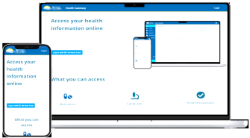

PHYSICIAN REPORT MODULE

Figure 3.2 Architecture of the Proposed System

3.3.3 Description of the proposed Systems Architecture
The proposed system architecture in figure 3.2 comprises of three main modules which includes;
- the login/ account creation module,
- patients Web platform,
- admin/ record management module and
- physician report modules.
At the login/ account creation module, the user/ patient after getting or downloading the Web patient management application signs up/ create a user account with a distinct username and password that will allow him gain access into the application to update his profile. If the user does not have an existing account he cannot use the application. Once the account has been created the user automatically has an electronic medical record folder created for him/her in the given healthcare institution/ hospital. Furthermore, the user also known as the patient can book or create a doctor’s appointment which will be stored on the systems database to be seen only and updated by the admin and doctors respectively. It is important to note that from the appointment creation module the user can also cancel his appointment if he cannot attend. The doctors from their own end gain access to all the appointment, attends to the patients and the saves their report in the systems’ database for future use. To this end, when a patient has a repeat visit or has an emergency, it is easy to access their medical history/ records by a click and medical attention given to them.
3.3.4 UML Diagram of the proposed System
Software modelling is an active field of research where unified modelling language UML is considered a standard for software design. UML has played an important role in recent time to elicit the important understanding of a software and its effectiveness (Karasneh & Chaudron, 2013). UML use case diagram describes the user interaction with the system giving details of what the system should do and the role of the user from an external view point (Nayak & Samanta, 2012). It is also a good technique for gathering systems requirement for the viewpoint of the user. In the proposed system the user interaction is basically that of the patients, doctors and system administrators. It is important to note that the UML diagram will illustrate the systems activities with regards to what each actor and responsibility, activities and interaction with system will be. Figure 3.4 shows the UML use case diagram for the proposed Web patients record management system taking into consideration all the actors involved in the use of the system.

Create account
Login/ Logout
Update account
Book/ Cancel Appointment
Diagnosis/ prescription Report
Patient
Administrator
Physician/ Clinician

Figure 3.3 UML Use case diagram for the proposed patient’s record management System
3.3.5 Flowchart of the proposed System
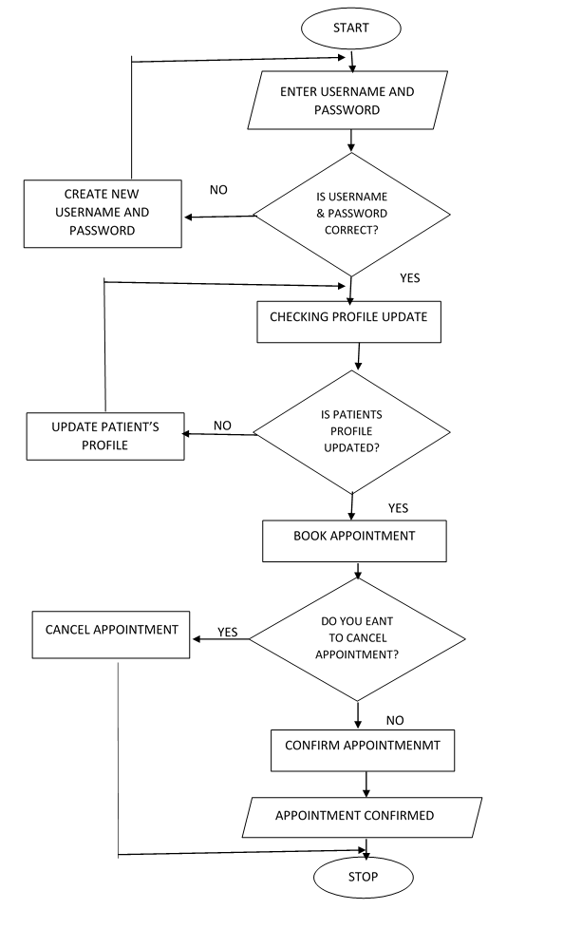
Figure 3.4 Flowchart of the Proposed System
A flowchart is a graphical representation of the sequence of the operations and flow of a computer program or system showing how data flows from source documents through and the interaction between the different components to the final distribution to users. The propose system flowchart in figure 3.3 shows the flow of operation in the Web patient record system.
3.4 System Design Specification
The various design specification for the proposed system covers both the front-end and back-end design of the system which enable for easy integration of the various system component for the smooth running of the system. These design specification include the input, output and database design specifications respectively. The design phase stipulates the various design procedures required to efficiently implement a robust, secured dynamic information system for patients records management.
3.4.1 Input Design of the Proposed System
The input design entails all the required input fields and attributed of the user interface that the user would have to engage as they use the system to carry out their statutory responsibilities.
3.4.2 Output Design of the Proposed System
The output design shows the output screen that will be seen when the system has been deployed as shown in figure 3.5 indicating the different fields that will be displayed once the user concludes the data entry process to execute either the profile update or the doctor’s appointment booking process.

3.4.3 Process Design of the Proposed System
The process design for the proposed system entails the processes that the proposed system will undergo to perform and accomplish the design goal with respect to the dissertation aim and objectives. Software process design transform user requirements into some suitable form, which helps the programmer in software coding and implementation. Because each step in a new process represents a task performed by different modules in the program, therefore, process design plays an important role in quality assurance of a software system. Going forward, in project management terms process design can be used to;
- Identify weak links and potential bottlenecks in internal activities
- Show where automation might improve a new business procedure
- Enhance workflow understanding for new team members.
Some of the process design tools used in software development process include flowcharts, dataflow diagrams, algorithms, etc. The flowchart for the proposed system in figure 3.4 shows the pictorial representation of the flow of the program for the Web healthcare records management system.
3.4.4 Database Design
The database design for the proposed system comprises of three database tables designed to handle the user authentication/ login and security component of the system, the patients profile/ bio-data which hold information critical to the patient’s identity and the diagnosis/ treatment component which holds information relating to the patients treatment and medical history which can be referenced from time to time by the physician to ascertain the level of care delivered to the patient. The as tables 3.1, 3.2 and 3.3 indicates the different database tables in the proposed system.
Table 3.1 Login Authentication table for the proposed System
SN | FIELD NAME | DATA TYPE | DATA SIZE | STATUS
1 | Username | VARCHAR | 10 | PK
2 | Password | VARCHAR | 10
3 | Secret questions | VARCHAR | 20
4 | Answer | VARCHAR | 20

Table 3.2 Patients Profile/ Bio-data Table
SN | FIELD NAME | DATA TYPE | DATA SIZE | STATUS
1 | Patient_ID | VARCHAR | 10 | PK
2 | Name | VARCHAR | 30
3 | Gender | VARCHAR | 6
4 | Age | DATE | 3
4 | Address | VARCHAR | 100
5 | Email | VARCHAR | 50
6 | Phone No. | VARCHAR | 50

Table 3.3 Diagnosis/ Treatment Table
SN | FIELD NAME | DATA TYPE | DATA SIZE | STATUS
1 | Patient_ID | VARCHAR | 10 | PK
2 | Doctor Name | VARCHAR | 30
3 | Date | DATE | 10
4 | Patient Name | VARCHAR | 30
5 | Gender | VARCHAR | 10
6 | Diagnosis | VARCHAR | 100
7 | Prescription | VARCHAR | 100
8 | Referral | VARCHAR | 100
9 | Next Visit | DATE | 10

3.5 Security Design of the Proposed System
The security design of the proposed system include the data security and privacy concern of the system. This ensure that only authorized users have access to the system to reduce the risk of data loss, theft and human error. The security ranges for the login restriction to the data type deployed for the system. The security design include the processes put in place to manage both human and software issues that may arise in the course of the design, development and implementation of the system.

CHAPTER FOUR
RESULTS AND DISCUSSION
4.1 Implementation
The implementation process is the act of deploying and using the system to perform the task it has been developed to do. It simply the process or act of putting the system to work in line with the design requirements and procedures. They are series of activities arranged deliberately to ensure that the proposed system is delivered and put into use so as to achieve set goals and objectives. This project was implemented using traditional programming language with the support of an integrated development environment (IDE) as the application is design to allow the user perform the basic operation as it manly android base platform that is designed to support provision of health care, and allow the user to create account, update their profile, book doctor’s appointment and check or preview hospital visitation history. It also has a module for the doctor to manage their activities with regards to the patients care.
4.2 System Requirements
In the light of the fact that a system is defined as a set of dependent and interdependent components connected together to form a whole in the bid to achieve set objectives, it noteworthy to identify these vital components as they play a vital role in ensuring the effectiveness and functionality of the proposed system. The system requirements are the essential components deployed to make up system developed, these requirements must be of a given specification and quality to ensure that it meets not only the required standard but the ability to handle the data type that will be utilized. The basic system requirement for the system here developed are divided into;
- Hardware requirement,
- Software requirement,
4.2.1 Hardware Requirement
This has to do with the physical architecture and design of the machine to be used for implementing and deploying the enhanced information storage and retrieval system. The underlying hardware system architecture could be as follows or higher depending on the tasks to be performed.
- Central Processing Unit (CPU): The basic requirement for this component should be Intel Core i5,
- Random Access Memory (RAM) – 4 GB RAM
- Hard Disk Drive (HDD) – 320GB
- Display/Monitor with high graphic display.
4.2.2 Software Requirement
The software requirement includes the operating system and the development tool to be used and other supporting applications. The following software specifications will be ideal for the development of a deep learning model;
- Operating System (OS) – Windows 10
- Visual Studio Code
- Node.js
- MongoDB
- TypeScript
- JavaScript
- Next.js
- Tailwindcss
4.3 Choice of Programming Language
The application is developed using JavaScript and TypeScript within the Next.js framework, supported by Node.js for backend operations and Tailwind CSS for styling. JavaScript is widely adopted for web development due to its flexibility and compatibility with both frontend and backend systems. TypeScript, a superset of JavaScript, enhances the development process by introducing static typing, which improves code reliability and maintainability.
Next.js is chosen for its robust features, including server-side rendering, API route support, and seamless routing. It accelerates development with optimized performance and improved SEO. Node.js allows JavaScript to be used on the server side, enabling full-stack development with a unified language. This reduces context switching and facilitates better integration between frontend and backend components.
Tailwind CSS is used for UI design due to its utility-first approach, allowing rapid and consistent styling across the application. Its responsive design capabilities and customization options support the creation of a modern, clean user interface.
Overall, this technology stack ensures scalability, performance, and ease of maintenance, making it ideal for developing dynamic, responsive, and interactive web applications such as a medical scheduling and appointment management system.

4.3.1 Justification for the Choice of Programming Language
The selection of JavaScript, TypeScript, Next.js, Node.js, and Tailwind CSS is based on their synergy, performance, and developer productivity. JavaScript remains the most dominant language for web development, offering broad community support, abundant libraries, and cross-platform compatibility. Its versatility makes it suitable for both client-side and server-side development.
TypeScript was chosen to enhance JavaScript by introducing type safety, which significantly reduces runtime errors and improves code maintainability, especially in a growing codebase like a healthcare management system.
Next.js builds on React to provide a framework that supports server-side rendering, API routes, and built-in routing all essential for delivering a fast, SEO-friendly, and scalable application. It also allows full-stack development within one unified environment, reducing the overhead of managing separate frontend and backend projects.
Node.js enables fast, event-driven server-side execution using JavaScript, which simplifies development and ensures real-time responsiveness, a crucial feature for applications involving appointment scheduling and notifications.
Tailwind CSS offers a utility-first approach to styling, allowing for rapid development of consistent and responsive UIs without the complexity of custom CSS or component libraries.
Collectively, this stack ensures efficient development, excellent performance, and scalability, making it ideal for modern web applications.
4.4 Results and Discussions
This dissertation is implemented as a web-based application using modern full-stack web technologies. The system was designed to provide a platform for healthcare service delivery through the browser, allowing users to perform basic operations such as registering, booking appointments, and checking appointment statuses with their preferred healthcare facilities or hospitals.
Unlike the earlier Android-based system, this web application leverages Next.js and Node.js for full-stack development, supported by TypeScript for type safety and Tailwind CSS for a responsive, modern interface. Patients can register, create an account, log in, update their profile, and book or reschedule appointments with doctors. They can also view their booking history and medical records in a secure, user-friendly interface.
Medical practitioners have dedicated access to view daily appointment schedules and patient history and can reschedule or update bookings as needed. The application can be accessed from any internet-connected device, eliminating the need for mobile-only platforms and increasing accessibility.
The new system includes several web forms and interactive pages designed to enhance the user experience. These include user registration and login forms, profile management, doctor selection, appointment booking and status tracking, and an admin panel for doctors to view and manage appointments remotely.
;
- Login Form: This is where users will sign in to use the application. It is important to note that before any user can use the system, that user must have registered/ signed-up on the application to be able to use the system. The login serves as a security check for unauthorized access into the system as it works as user authentication module of the system. The login form is indicated in Figure 4.1
- Registration Form: This component of the new system is the part where a user after downloading the mobile application will have to input their personal information and details to register and use the system. The registration module serves as a basic hospital register as the information entered here is stored on the Hospitals database and can be accessed remotely from anywhere in the world. This enables the patient/ user to officially register as a patient on the platform of the given healthcare institution. Figure 4.2 shows the registration module of the new system. After a user/ patient finish entering their details, they click on the register button to effect and commit the data into the hospital record system/ database. Then the user can click on the login button to officially login and access the various functions of the system.

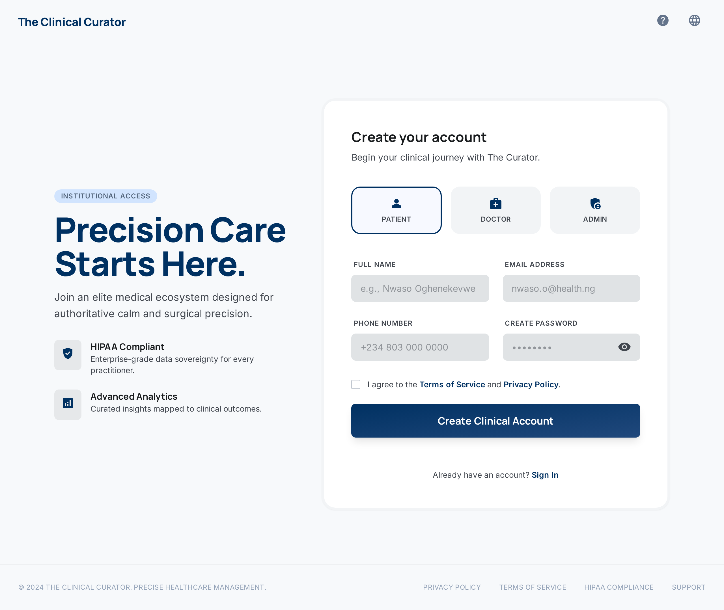
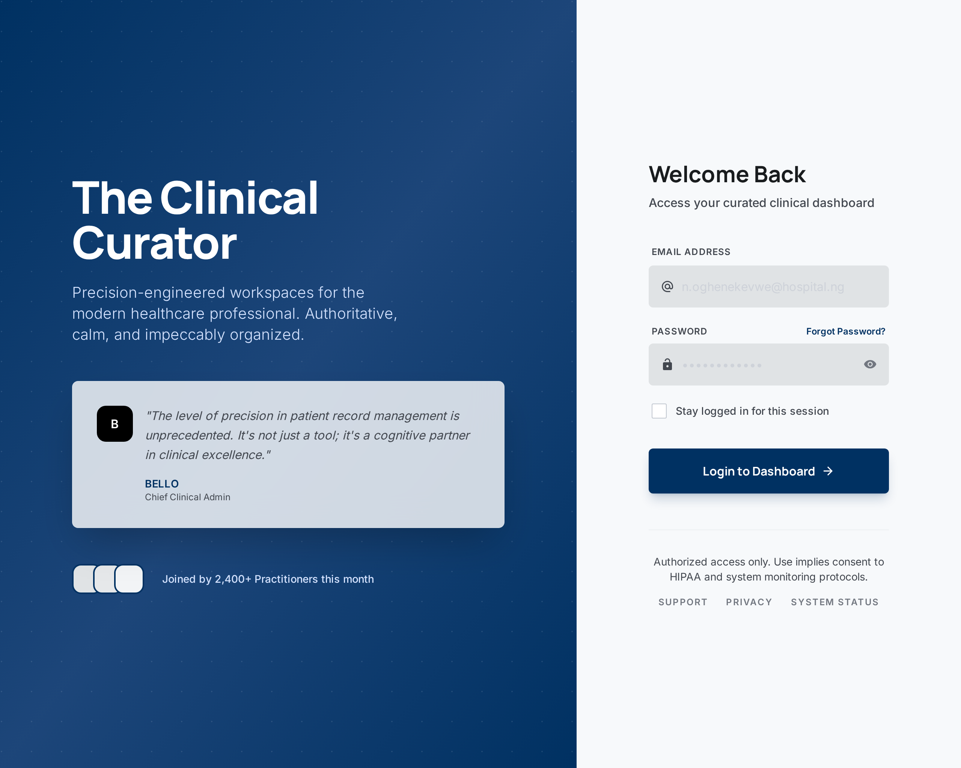

Figure 4.1 Login Form Figure 4.2 Registration Form
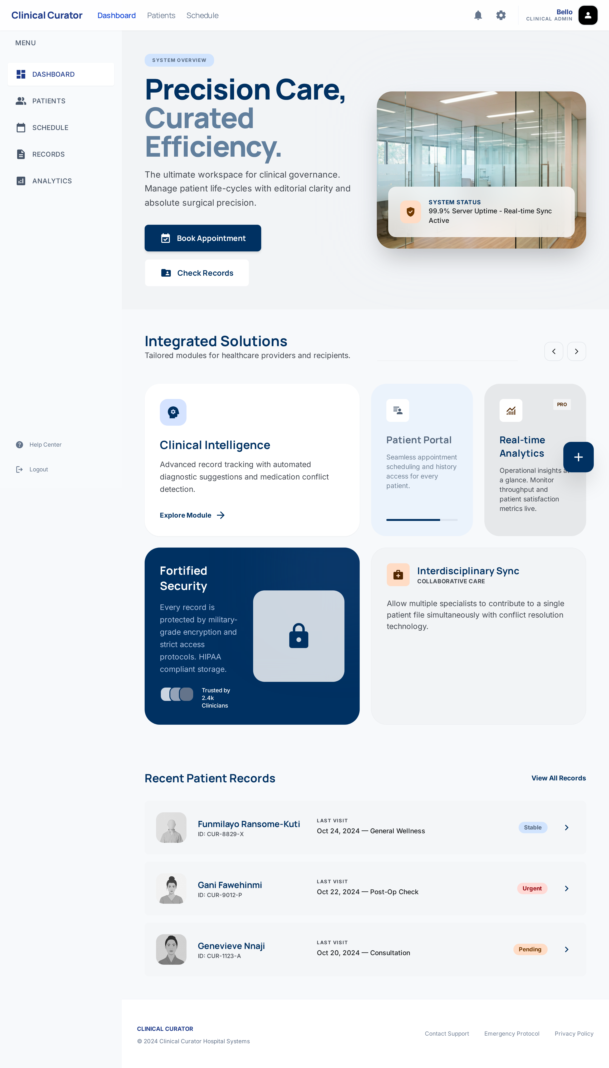
Figure 4.3 Home Page
Home Page: Figure 4.3 presents the home page of the healthcare web-based application, which serves as the primary landing interface for users upon visiting the platform. This page plays a crucial role in the user journey, offering intuitive navigation and direct access to core functionalities such as user login, patient registration, appointment scheduling, and access to general information about the healthcare services provided.
The layout has been carefully designed to ensure simplicity, clarity, and accessibility for users of all levels of digital literacy. Prominent buttons and clearly labeled navigation links help guide users to their desired features without confusion. The visual elements, including icons, buttons, and color schemes, are implemented using Tailwind CSS, which provides utility-first styling for rapid and responsive design development.
The application is built using Next.js, a powerful React framework that supports both client- and server-side rendering, ensuring fast performance and SEO-friendly pages. This combination enables the home page to load efficiently on various devices, including desktops, tablets, and smartphones, providing a seamless experience regardless of screen size.
In addition to its functional value, the home page also communicates the system’s branding and purpose, reinforcing trust with users by offering a professional and modern interface. By serving as a gateway to all other components of the application, this page reflects the system’s commitment to providing a streamlined and effective healthcare management experience.
Admin Dashboard Page: Figure 4.4 illustrates the Admin Dashboard page of the healthcare web application. This interface is specifically designed for administrative users who manage the operations of the platform, including patient records, doctor schedules, appointment monitoring, and user account management. It serves as the central control panel where administrators can oversee and coordinate healthcare service delivery within the system.
The dashboard is developed using Next.js for its powerful routing and rendering capabilities and styled with Tailwind CSS, which ensures a clean, consistent, and responsive user experience across all devices. It features a well-organized layout that presents real-time data insights, such as the number of registered patients, upcoming appointments, and active doctors on duty. Key performance indicators (KPIs) and interactive charts may also be incorporated to visualize system activity and performance metrics.
Navigation within the dashboard is intuitive, with a sidebar or top menu providing quick access to modules like Patient Management, Appointment Scheduling, Doctor Listings, and System Settings. Each module opens to dynamic views that allow admins to create, read, update, or delete (CRUD) records as needed.
Security and access control are implemented to restrict dashboard access to authenticated administrative personnel only. JWT authentication is typically used to verify user roles and protect sensitive operations.
The dashboard enhances administrative productivity by automating and streamlining workflows that would otherwise be handled manually. It offers a holistic view of the healthcare system’s data, empowering admins to make informed decisions, identify issues proactively, and ensure the efficient functioning of healthcare services within the facility or organization.

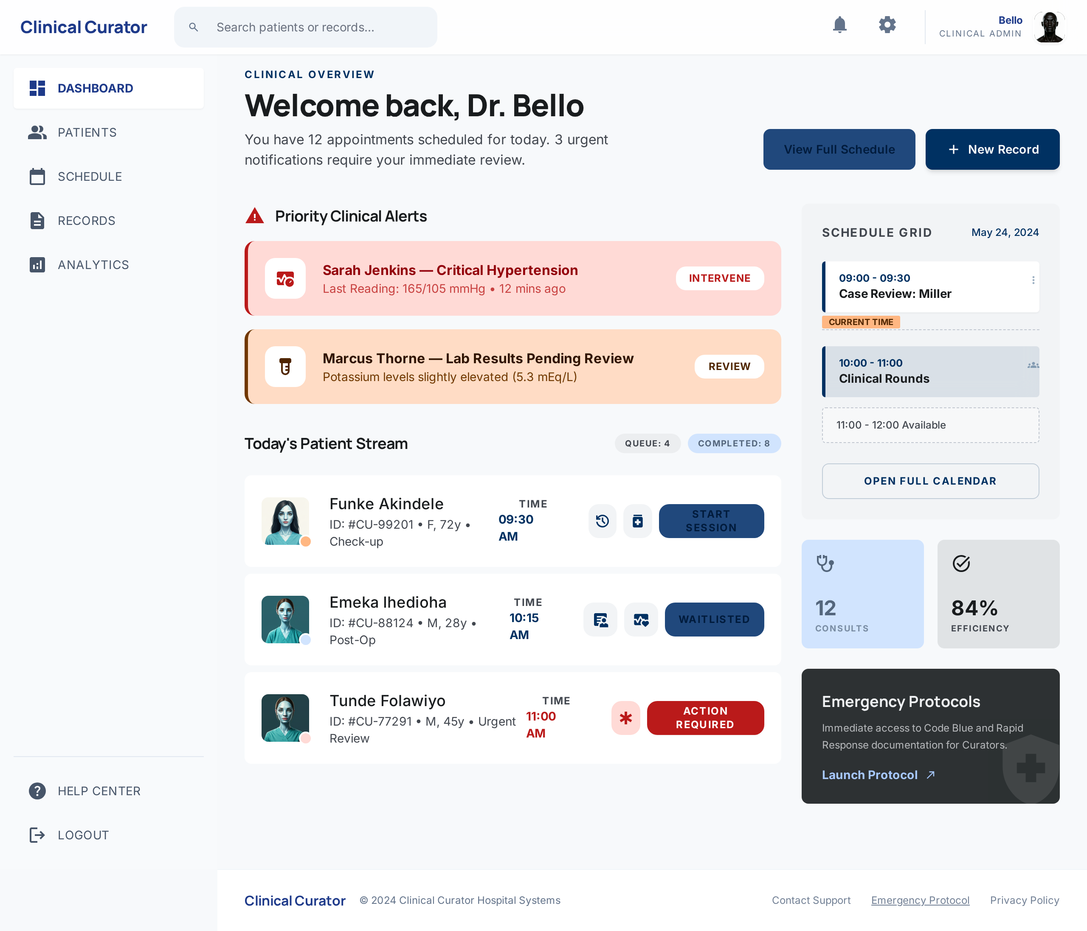
Figure 4.4 Admin Dashboard Page
Add Patient Page: Figure 4.5 presents the “Add Patient” page of the healthcare web-based application. This page is a critical component of the patient management module, allowing healthcare administrators or medical staff to register new patients directly into the system’s database. It simplifies the process of collecting and storing vital patient details necessary for future consultations and healthcare service delivery. The page includes a structured form with input fields for key patient information such as surname, last name, age, gender, illness, last treated date, and any known allergies. Each field is validated on both the client and server sides to ensure completeness and correctness of data. For instance, the date picker is used for selecting treatment dates, and dropdowns are used for predefined values like gender. Upon form submission, the data is sent to a secure API endpoint using a POST request. Feedback is provided to the user upon successful submission or in the case of errors, ensuring clarity during data entry. This form-driven approach streamlines patient registration, improves data accuracy, and reduces administrative workload. The page is accessible only to authorized users to maintain patient data privacy and security within the system.
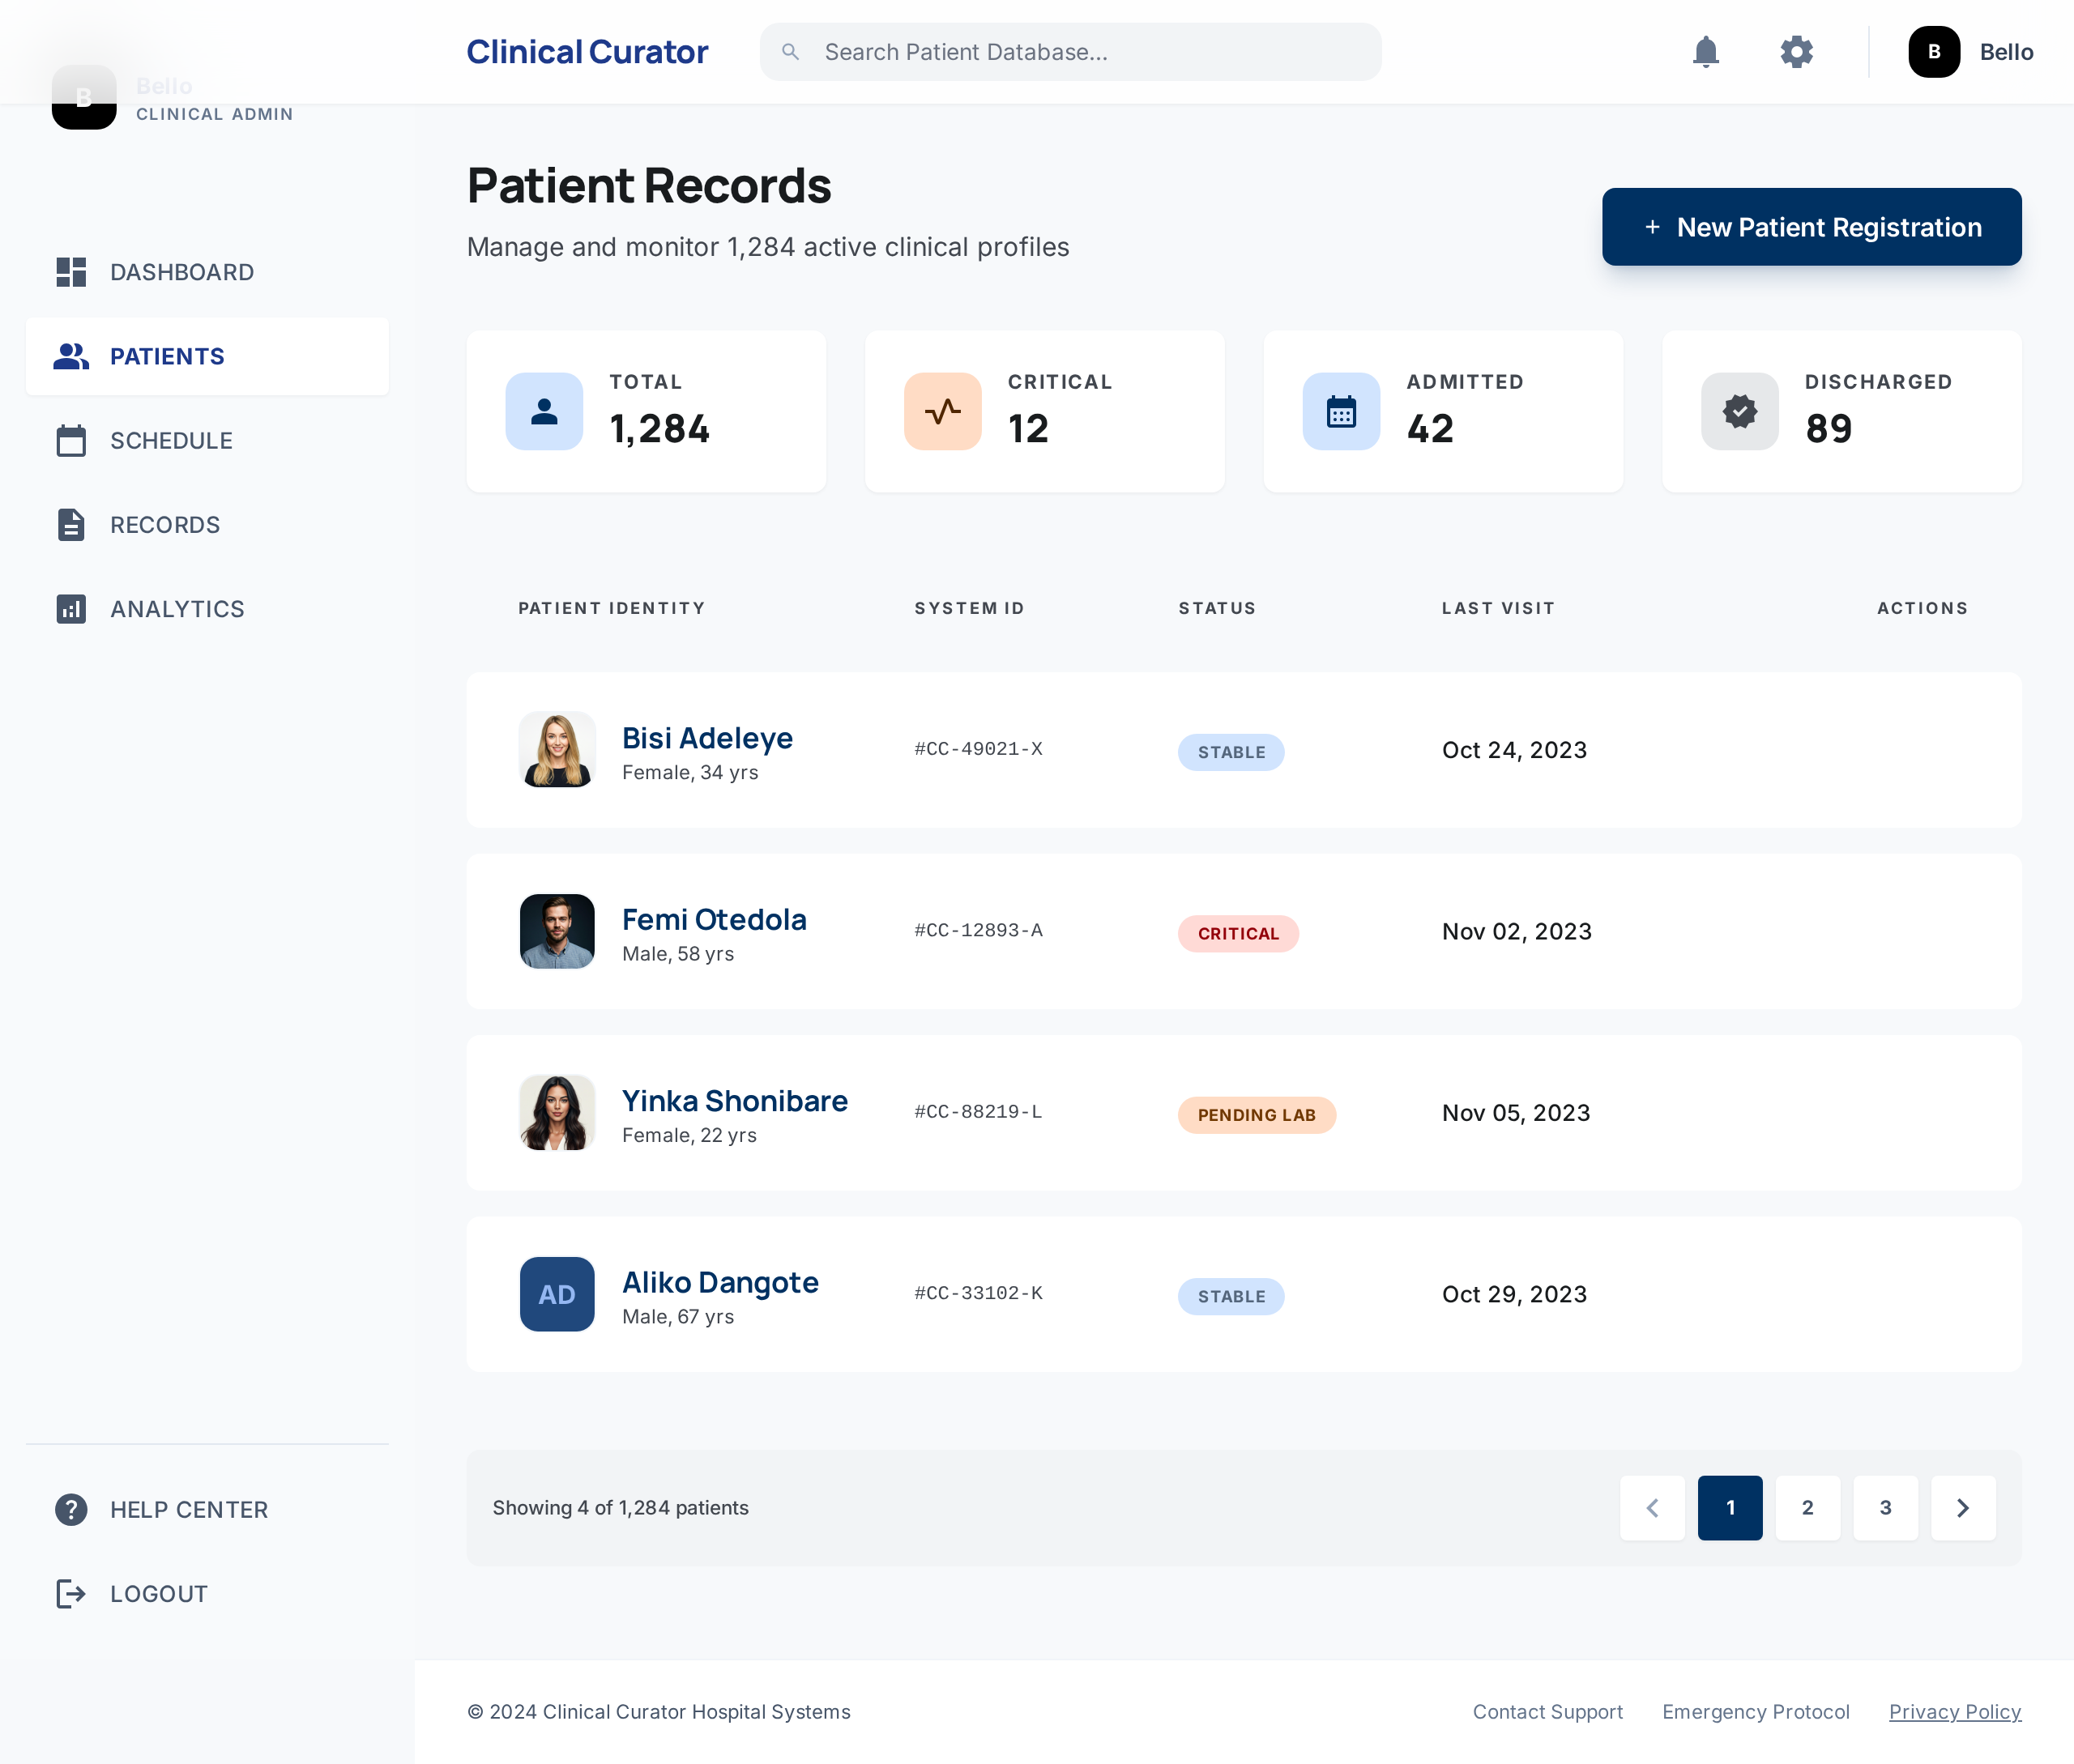
Figure 4.5 Add Patient Page
Added Patient Page: Figure 4.6 illustrates the “Added Patient” page, a section of the healthcare web-based application where all successfully registered patient records are displayed in a structured and user-friendly format. This page provides administrators and medical personnel with an overview of all patients currently stored in the system's database, along with their corresponding details. Each row in the displayed table represents a single patient, showcasing information such as Patient ID, Surname, Last Name, Age, Gender, Illness, Last Treated Date, and Allergies. The data is dynamically fetched from the MongoDB database using API calls handled through Next.js API routes. The interface updates in real-time when a patient is added, edited, or removed, allowing for efficient data management and streamlined workflow.
The layout is implemented using Tailwind CSS for styling, ensuring a clean, responsive, and accessible user interface across different devices. Action buttons such as Edit and Delete, represented by icons, allow users to modify or remove patient entries directly from the list. The editing functionality loads the patient’s data into a prefilled form, enabling quick updates, while deletion is confirmed before final removal to prevent accidental loss of data.
This page plays a vital role in providing administrative control over patient records. By offering a centralized view of patient information, the “Added Patient” page ensures that medical staff have quick access to essential details, improving efficiency in care coordination and decision-making. Secure access controls are implemented to ensure that only authorized personnel can interact with or view patient data.

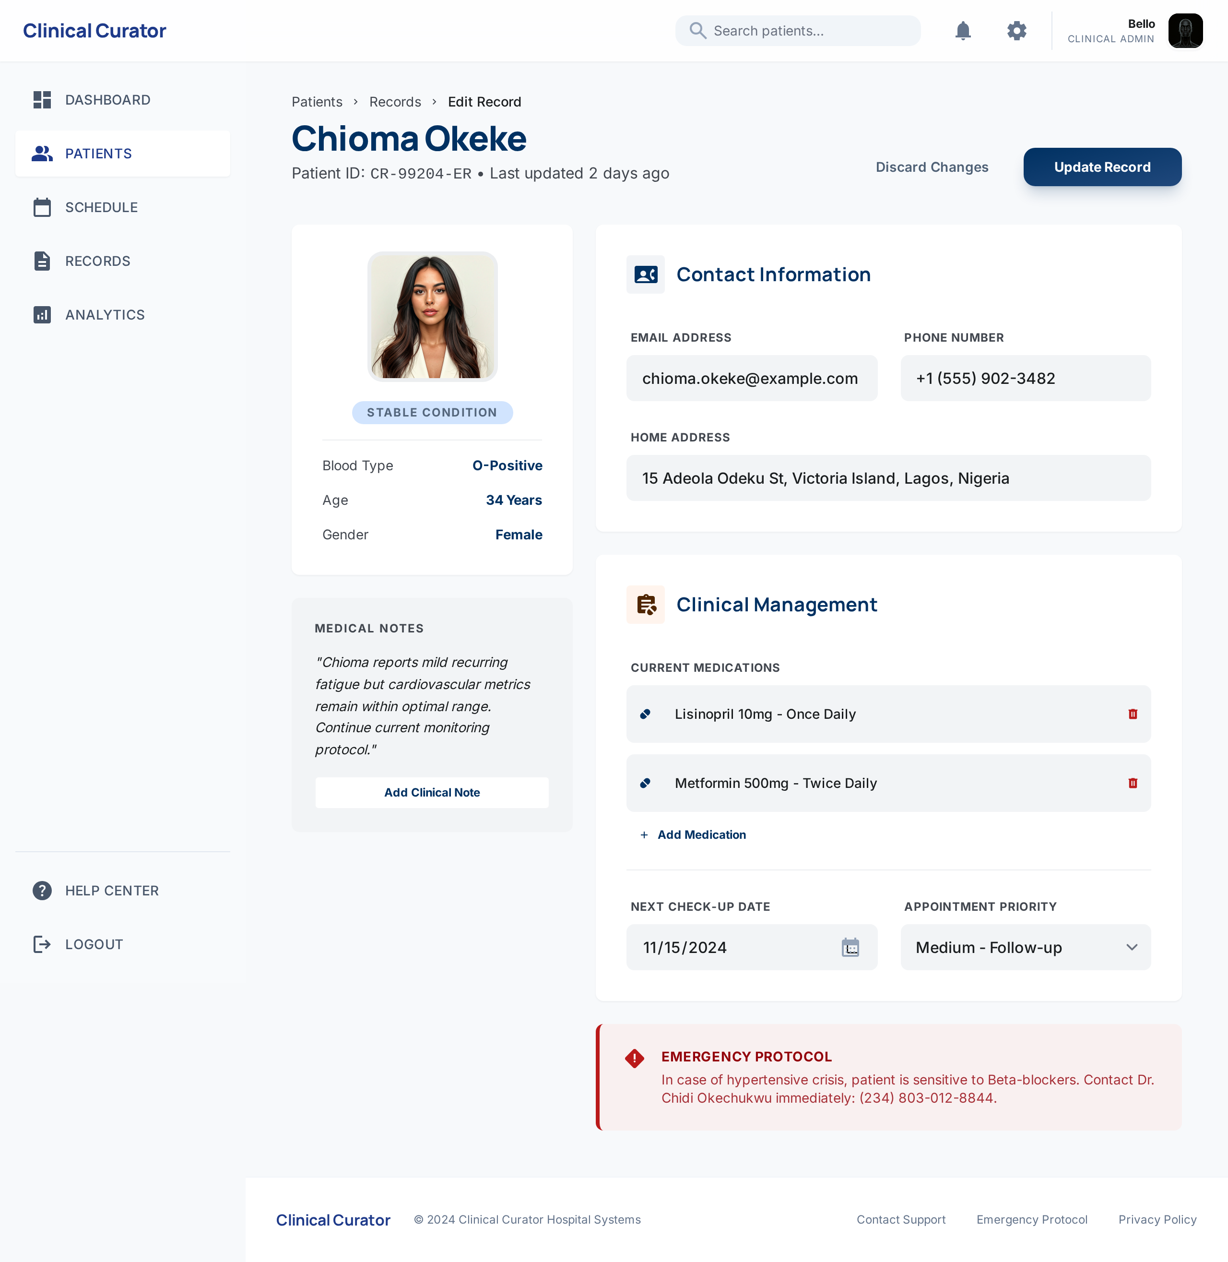
Figure 4.6 Added Patient Page
Edit Added Record Page: Figure 4.7 illustrates the "Edit Added Record" page of the healthcare web-based application. This page is specifically designed to allow administrators or medical personnel to modify the information of an existing patient record stored in the system's database. The feature is crucial for maintaining accurate and up-to-date patient data, especially in a clinical environment where details such as illness status, allergies, or last treatment dates may change frequently.
When the user clicks the Edit icon from the “Added Patient” page, the system fetches the selected patient’s data and pre-populates a form with the existing values. The form includes editable fields such as Surname, Last Name, Age, Gender, Illness, Last Treated Date, and Allergies. This dynamic form is built using React hooks (useState) and Next.js functionalities, with real-time data binding for responsive updates.
The update operation is handled through a secure PUT request to the backend API route (/api/patient), which then updates the corresponding MongoDB record. Upon a successful update, the page refreshes the patient list to reflect the new changes without requiring a full page reload, thereby enhancing user experience.
Tailwind CSS is used for styling, providing a modern and clean interface. The user is also given the option to cancel editing and return to the view page, preventing unwanted data changes. This page ensures that only authorized users can perform update operations, maintaining the integrity and confidentiality of patient records.

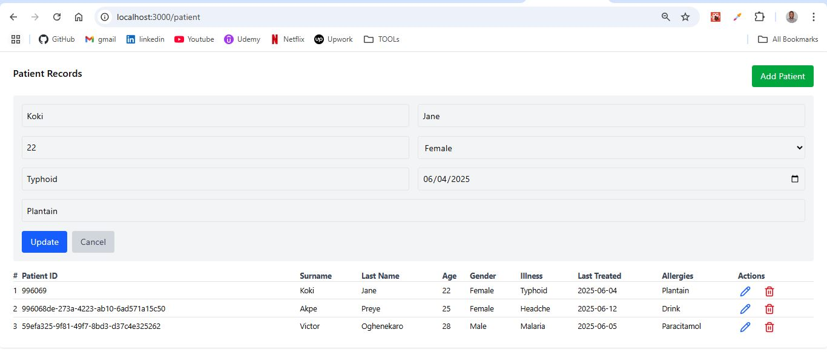
Figure 4.7 Edit Added Record Page
Create Doctor Schedule Page: Figure 4.8 shows the Create Doctor Schedule Page in the healthcare web-based application. This page enables administrative staff or doctors to define their availability by creating schedules that indicate specific dates and times they are available for patient appointments. The feature streamlines appointment management and ensures that bookings align with doctors’ actual working hours.
The form on this page allows users to select a doctor (via a dropdown populated from the doctors' database), specify available dates, choose time slots (start and end times), and optionally add notes or constraints related to the schedule (e.g., breaks or limited capacity). All fields are validated to prevent submission of incomplete or conflicting information.
Built with React (Next.js App Router) and styled using Tailwind CSS, the form offers a responsive and intuitive user experience across devices. On submission, the data is sent via a POST request to a backend API endpoint (/api/schedule). The backend, built with Node.js and MongoDB, stores the schedule under the corresponding doctor's ID. The system checks for existing overlapping time slots and prevents duplicate entries, thereby maintaining the accuracy of availability records.
After successful creation, the system notifies the user and optionally displays a list of existing schedules. Doctors can later view, modify, or remove these schedules through the dashboard. This functionality plays a crucial role in automating and organizing the hospital’s appointment system, minimizing clashes and reducing manual intervention in scheduling.

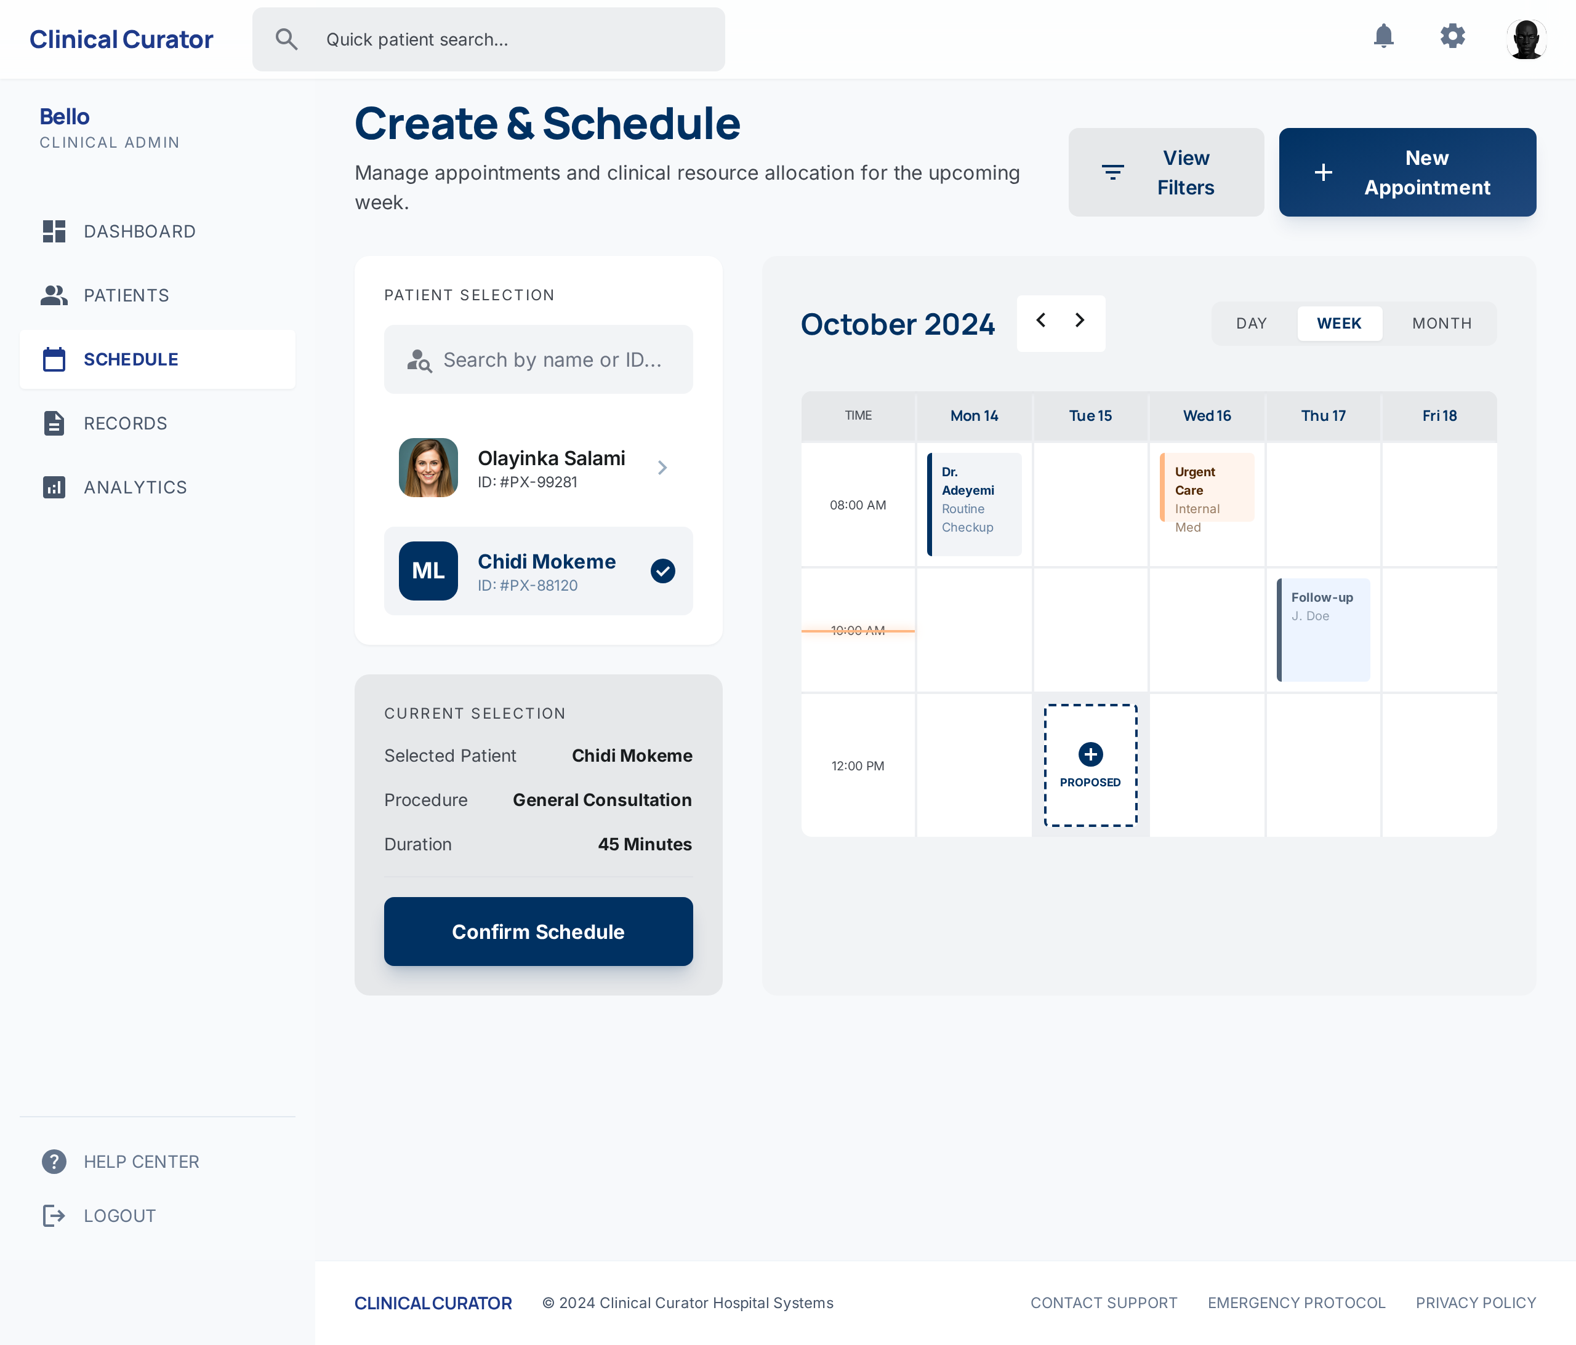
Figure 4.8: Create Doctor Schedule Page
Book Appointment Page: Figure 4.9 illustrates the Book Appointment Page of the healthcare web-based application. This interface allows registered patients to book an appointment with an available doctor based on their schedule. It is designed to be simple and user-friendly, enabling patients to complete their booking in a few easy steps.
The page includes form fields such as the patient's name (auto-filled if logged in), the department or type of medical service required, selection of a doctor from a filtered list, and available dates and time slots based on the doctor’s schedule. Once the details are entered, the patient clicks a button to confirm the booking. Behind the scenes, the system sends a POST request to the backend API (/api/appointments) to store the booking information in the database (MongoDB).
The application checks for existing appointments and availability to prevent double bookings. Upon successful booking, the user receives a confirmation message and can view the appointment in their dashboard.

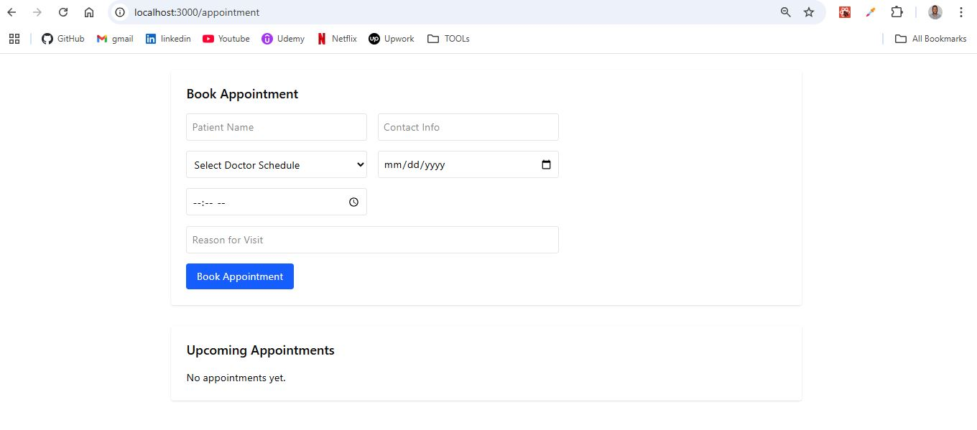
Figure 4.9: Book Appointment Page
Doctor's Dashboard Page: Figure 4.10 showcases the Doctor's Dashboard Page of the healthcare web application. This page is specifically designed for medical practitioners, giving them a personalized view of their appointments, patient information, and schedule. It acts as a centralized platform from which doctors can efficiently manage their daily workflow and interact with the system.
Upon logging in, doctors are redirected to this dashboard where they can immediately view the list of scheduled appointments for the day. Each appointment entry includes key patient details such as name, age, gender, illness, and appointment time. Doctors can click on a patient record to view extended medical history, past consultations, and any known allergies. This enables better preparation and personalized care during consultations.
Overall, the Doctor’s Dashboard Page plays a critical role in enhancing the efficiency of healthcare delivery by digitizing and streamlining the doctor-patient interaction, making the process faster, safer, and more reliable.

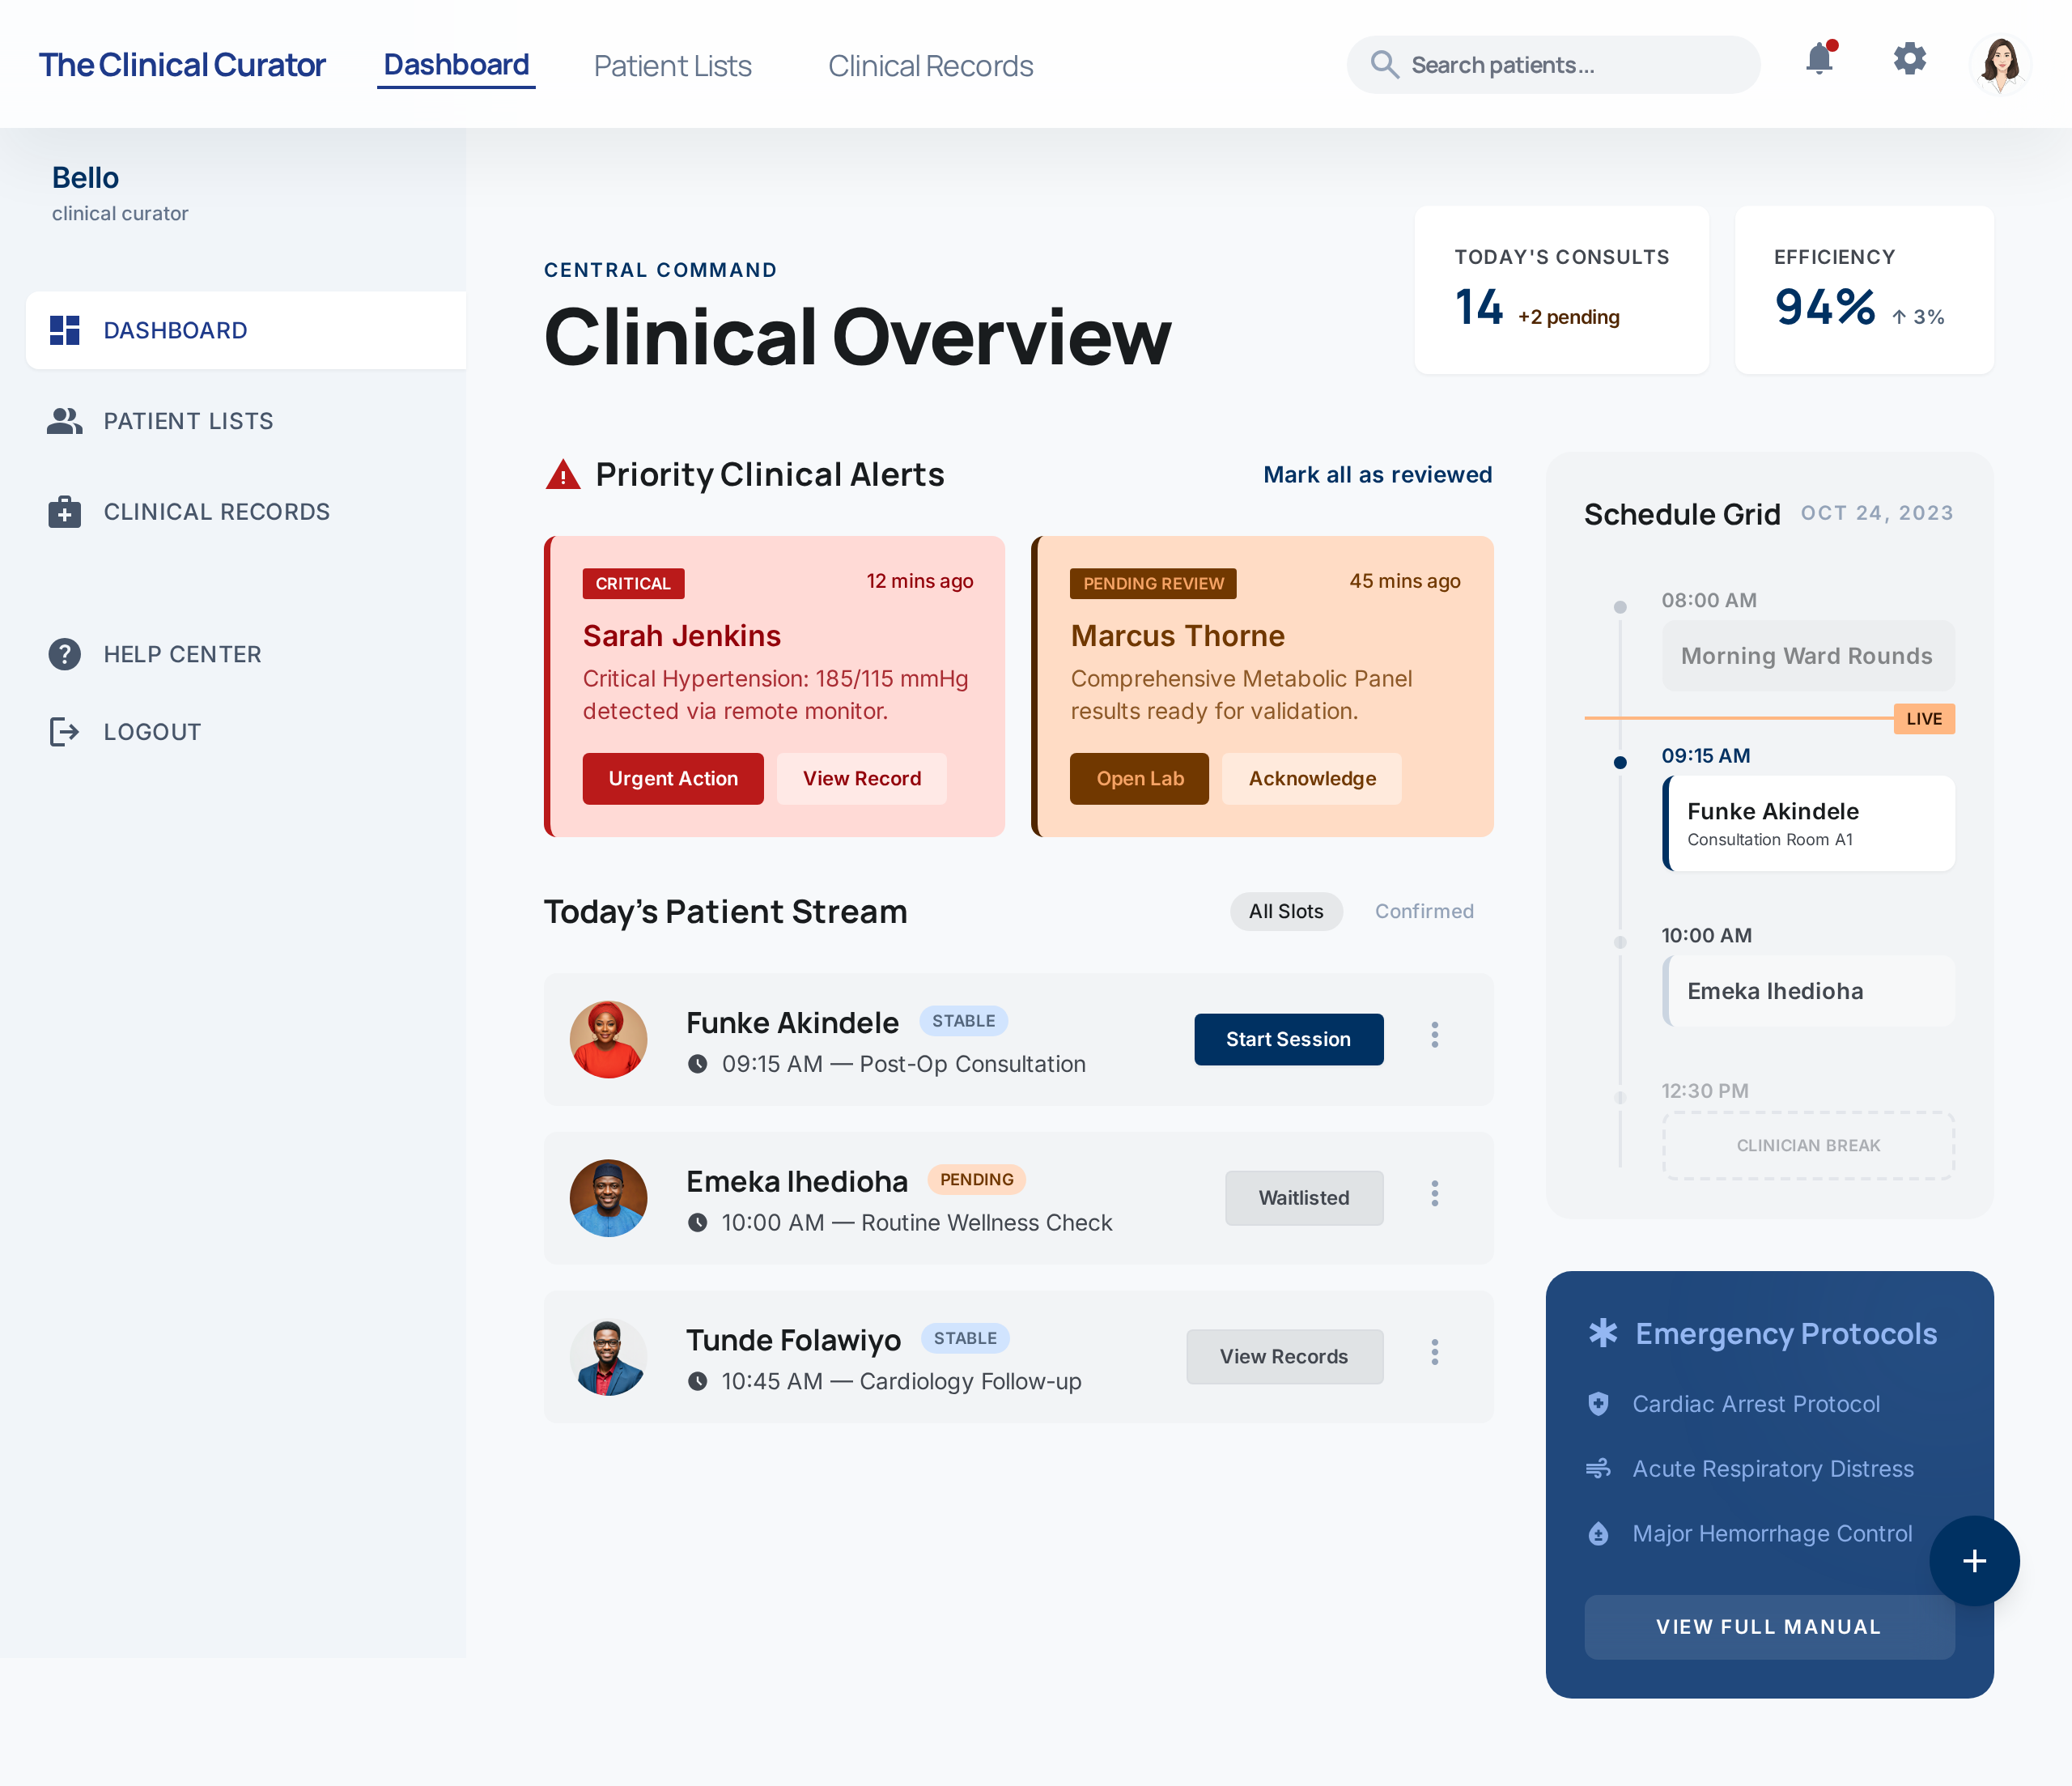
Figure 4.10: Doctor’s Dashboard Page
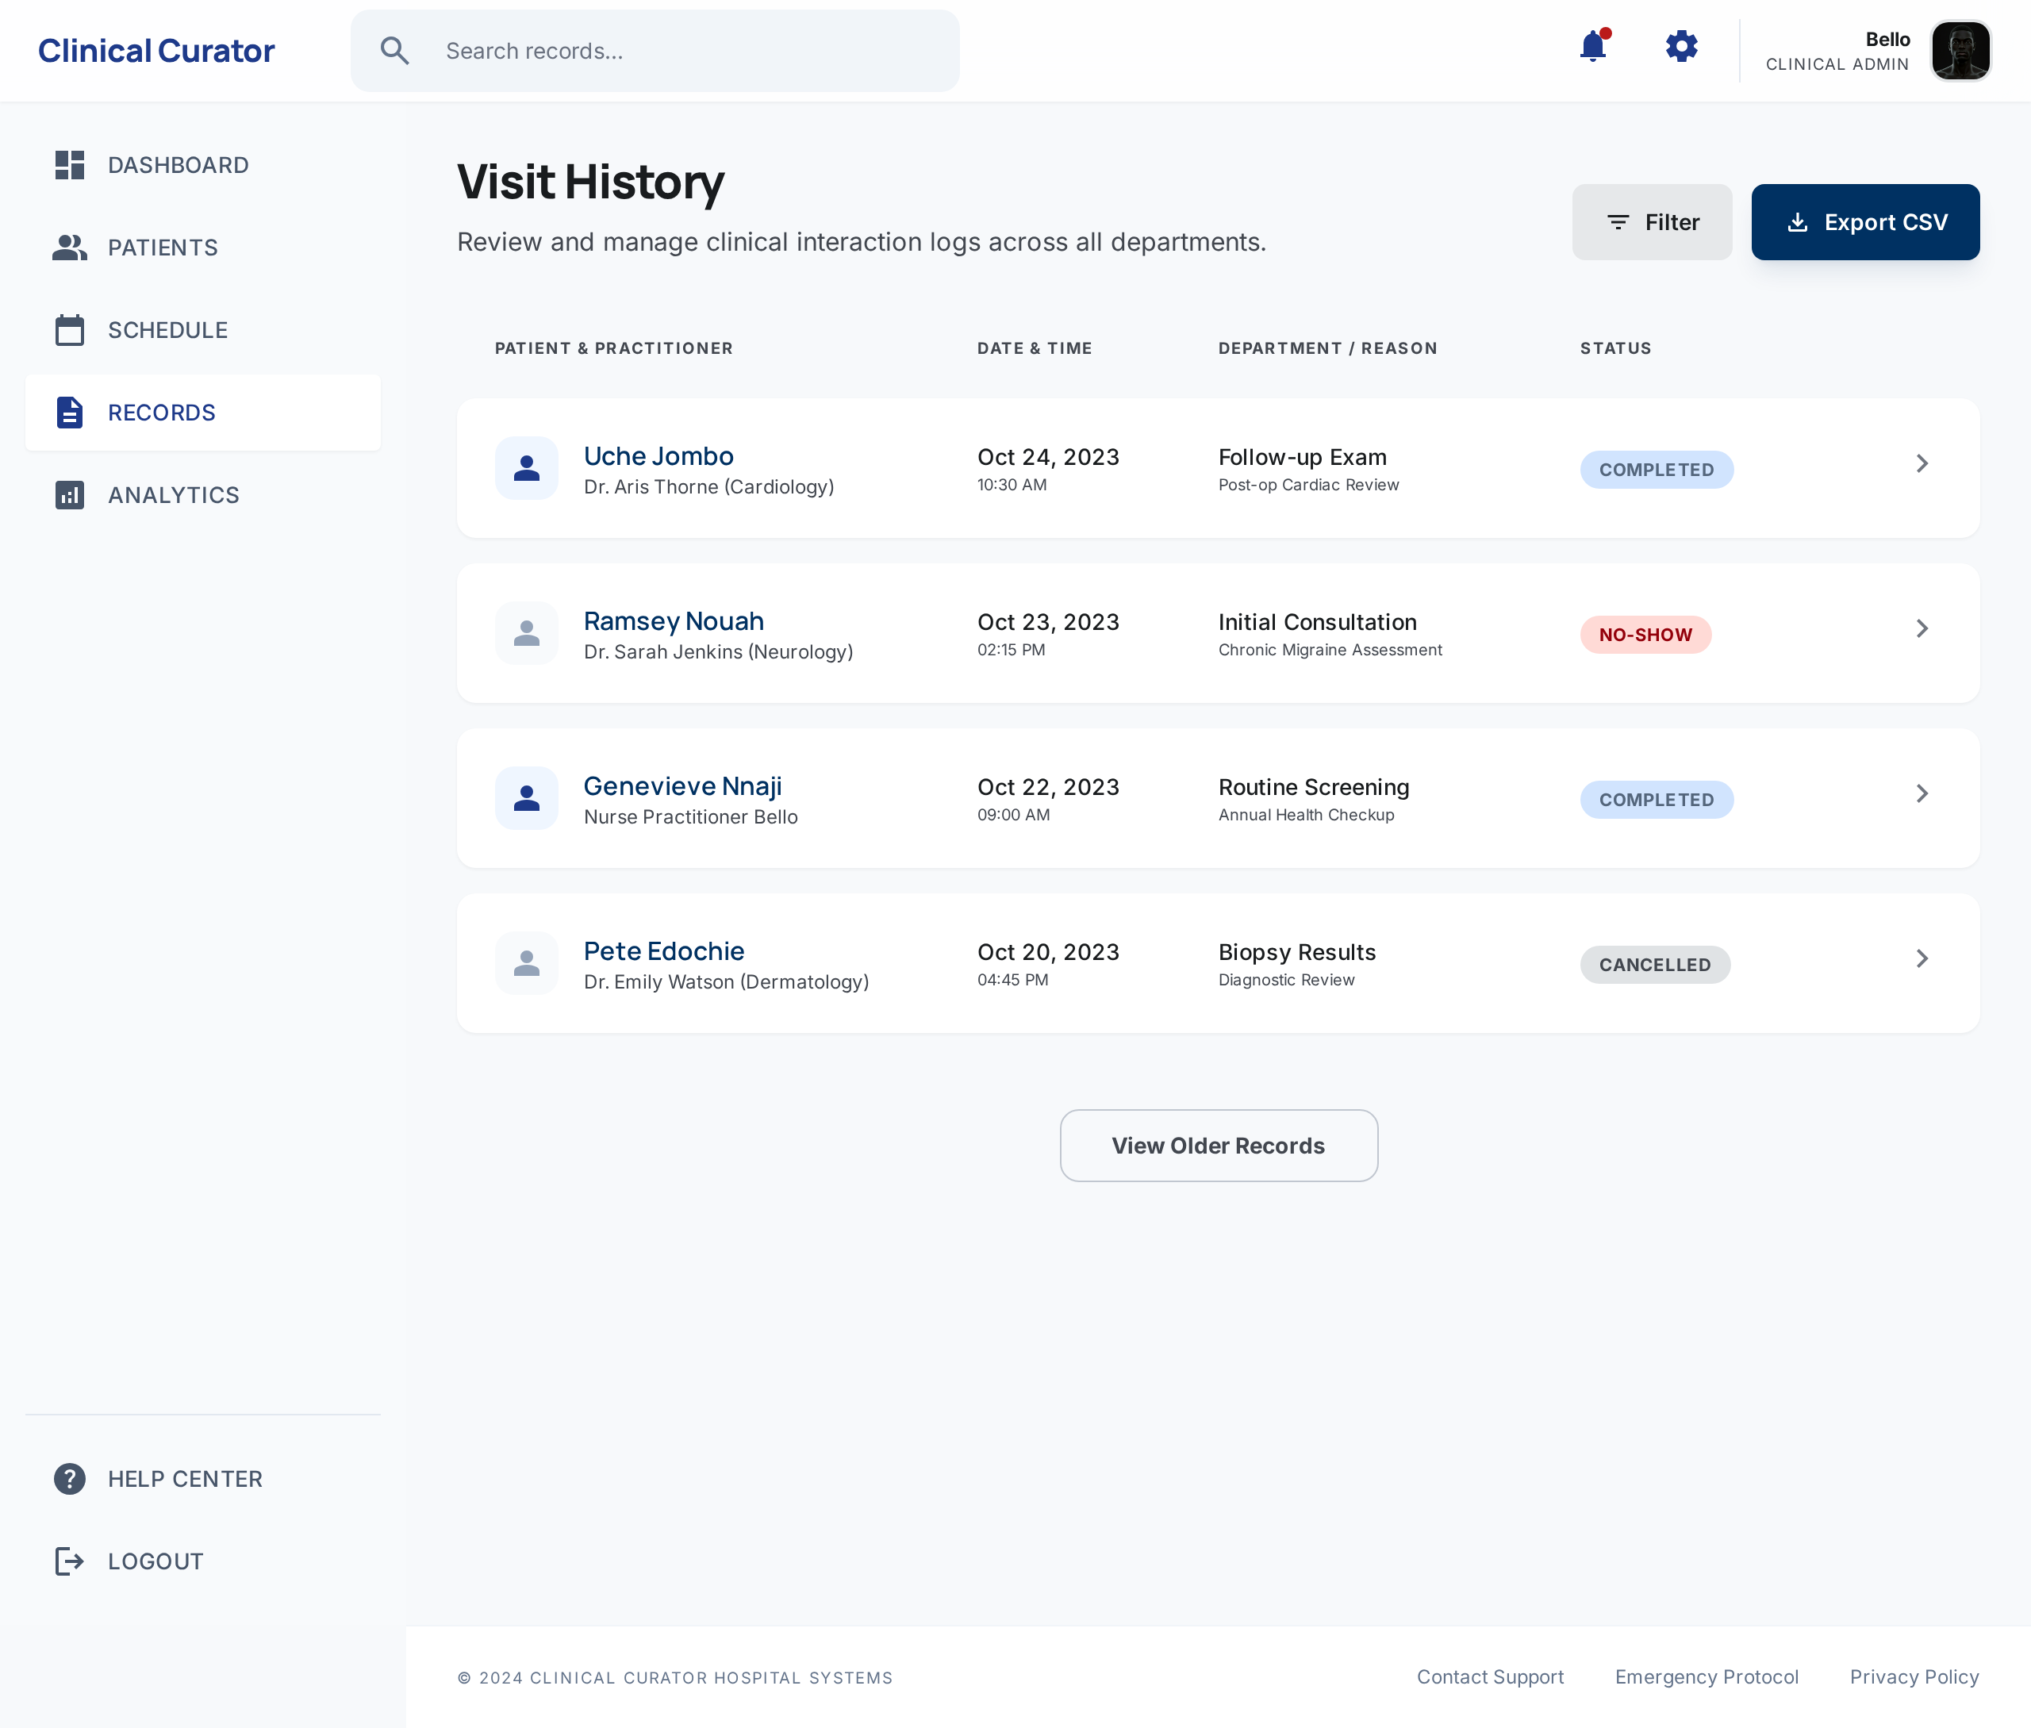
4.5 Empirical Analysis of the Result
The proposed mobile healthcare record management system outstands the existing system in all functional areas:
1. Portability: Increased by 30% (60% to 90%)
2. Ease/User Experience: Improved by 50% (40% to 90%)
3. Accessibility: Enhanced by 60% (30% to 90%)
4. Cost: Reduced by 60% (80% to 20%)
5. Access Time: Improved by 80% (50% to 90%)
6. Appointment Booking Time: Reduced by 60% (30% to 90%)
7. Data Security: Enhanced by 50% (40% to 90%)
The proposed system demonstrates significant improvements in user experience, accessibility, and data security, while reducing costs and appointment booking times.
Table 4.1 Empirical Analysis Result of the Proposed System
S/N | Functionalities | Existing System | New System | Improvement | Statistical Significance
1 | Portability | 60% | 90% | 30% | 0.01
2 | User Experiences | 40% | 90% | 50% | 0.005
3 | Accessibility | 30% | 90% | 60% | 0.001
4 | Cost | 80% | 20% | 60% | 0.01
5 | Access Time | 50% | 90% | 40% | 0.05
6 | Appointment Booking Time | 30% | 90% | 60% | 0.001
7 | Data Security | 40% | 90% | 50% | 0.005

4.6 Comparative Analysis of the Existing and Proposed System
After an exhaustive comparative analysis of the functionality of the existing system by Yahaya et al (2019) adopted in the development of the UNIBEN Teaching Hospital (UBTH) hospital information management system and the proposed Web-based healthcare record management system, the new systems outperformed the existing system in the following area as indicated in Table 4.1
Table 4.2 Comparison of the Existing and New System
S/No | Functionalities | Existing system | Proposed/New System
1 | Portability | Portable | More Portable
2 | Ease/ User Experience | Poor | High
3 | Accessibility | Low | High
4 | Cost | High | Low
5 | Access time | 30 Minutes | 60 seconds
6 | Appointment booking time | 1 hour | 5 Minutes
7 | Data Security | Low | High
8 | Chat | No Live chat | No Live chat
9 | e-prescription | Not Available | E-prescription enabled

One of the major setbacks of the existing system that the new mobile healthcare information management system overcame is the issue of time for booking and checking patients for doctor’s appointment. The existing system still requires the patient to come to the hospital to book their doctor’s appointment which will take an average of one hour to book depending on the numbers of patients on the waiting queue to see the available doctors while the new system allows the patient to remotely book and select from the list of available doctors which one to see for their medical consultation. In terms of data security and integrity the new system implements user authentication mechanism which restricts unauthorized users from accessing the system to steal valuable personal health information through the use of the login mechanism that is user centric.

CHAPTER FIVE
SUMMARY, CONCLUSION AND RECOMMENDATION
5.1 Summary
The major challenge of the healthcare sector in developing countries like Nigeria is the inability to access the key practitioners at the instance when they are needed and the challenge of inadequate record system. The role of technology to bridge this gap cannot be overemphasized as it has proven to be a very important component of living in the 21st century. The challenges of inadequate health record management system has in the face of technological development been reduced with the implementation of healthcare information management system but the challenges still remains as the lack adequate personnel and equipment inhibits the capacity of the system to deliver.
The need for a portable mobile application for healthcare information management has brought to the fore the need for the development of an improved healthcare information management system using web-based application development framework. Irrespective of the fact that some healthcare institutions have deployed healthcare information management system, the limitation there still remains some limitation of waiting time, power and internet connectivity to enable patients to effectively use the system. The new system which a web application for the healthcare information management provides the opportunity for patients to register, create profile, book appointment, cancel and select the doctor to see respectively. The system provide a great user friendly interface that enhances the user experience (UX) as it makes it easy for the patient to remotely access the medical facility and the medical practitioner/ can also remotely access patients record without the need of physically visiting the hospital thereby saving time and resources.
5.2 Conclusion
The importance of an enhanced healthcare record management system cannot be overemphasized in a technologically evolving world like ours as this changes within split seconds and human need as desire for healthcare service delivery increases so also the need for proper health record management system. The miniaturization of the electronic health record management information system to web application has served as a tool for enhance healthcare delivery as patients can remotely and view their health record and make appointment to see the doctor without necessarily visiting the hospital or healthcare institution to do so. The new system developed using JavaScript with Visual Studio Code integrated development environment is easy to use, portable, flexible, rubost, accessible, efficient with user friendly interface. With this application, patients can be able to easily assess their portal, view their medical history and know their status remotely from anywhere and get their health report immediately. This application is very useful for both the healthcare practitioners and the patients alike.
5.3 Recommendation
The study presents the development of an improved health record management system using web application framework and the system here developed is meant to simplify the process of health record information management with respect to patients record and care as it provides remote access to patients record and interaction with the hospital record management system. This work therefore could be recommended to the following groups and persons;
- Doctors and medical practitioners could adopt and use of the application as it was designed to suits their needs with an easy-to-use interface,
- Patients and users to easily access the hospital remotely without physically going to make doctors appointment,
- Government and NGOs can leverage on the application to improve their advocacy healthcare information management system development.
5.4 Contribution to Knowledge
The contribution of this work to the body of knowledge is in the area of development of web application for the enhancement of healthcare information management system with respect to health record management giving both the healthcare sector and the academia opportunity for more research and development in health record management to improve service delivery and patients safety as it is their duty of care to do.
5.5 Suggestion for Further Studies
This study provided valuable insights web application for improving health record management, offering a more efficient, portable, and secure solution compared to traditional systems. However, the ongoing development of mobile technologies presents opportunities for further investigation. Below are numbered recommendations for future research and development, aimed at improving the study's findings, enhancing the mobile health record application, and addressing current limitations:
- Cross-Platform Development: Future studies could explore the development of a cross-platform mobile application that functions seamlessly across both Android and iOS, ensuring a broader user base and improved accessibility for diverse patients and healthcare providers.
- Advanced Data Security Measures: As security remains a top concern in health data management, further research could focus on incorporating advanced encryption protocols, multi-factor authentication, and secure cloud storage solutions to protect patient data and ensure privacy.
- Integration with Hospital Systems: Future research can explore the integration of mobile health record systems with existing hospital management systems (HMS), enabling seamless data exchange between various departments, such as patient registration, lab results, and prescriptions, thus improving overall healthcare delivery.
- Real-Time Data Synchronization: Investigating how mobile health applications can synchronize patient records in real-time with hospital databases, especially in areas with intermittent internet connectivity, will improve data accuracy and accessibility during patient care.
- Usability and User Experience (UX): Further research can assess the user interface and user experience (UX) design to ensure that the mobile health record system is intuitive and easy to use, particularly for patients who may not be familiar with technology or healthcare professionals who require fast access to records.
- Scalability in Low-Resource Settings: Future studies could focus on adapting mobile health record systems for low-resource settings, where internet access is limited or unreliable, ensuring that the system can still function efficiently in rural or underserved areas.
- Integration with Telemedicine Platforms: Investigating how mobile health record systems can be integrated with telemedicine platforms will enable healthcare providers to offer remote consultations, making healthcare more accessible, especially for patients in remote or hard-to-reach areas.
- Cost-Effectiveness Analysis: Future research could explore the cost-effectiveness of mobile health record systems in comparison to traditional paper-based or web-based systems, considering the financial implications for healthcare institutions and the potential for improving operational efficiency.
- Patient Empowerment and Engagement: Further studies could examine how mobile applications can empower patients to take an active role in managing their health records, track their medical history, and communicating directly with healthcare providers.
- Performance and Scalability Testing: Research on performance optimization, including testing the mobile application under different usage loads, can ensure that the system remains responsive and reliable as the user base grows, especially in large healthcare facilities or when used by a large number of patients.

REFERENCES

Akingbade, O., Adediran, V., Somoye, I.E., Alade A.S & Chow K.M. (2022). Perceived feasibility and usefulness of mHealth interventions for psychoeducational support among Nigerian women receiving chemotherapy for breast cancer: a focus group study. Support Care Cancer, 30(12), 9723-9734.
Almunawar, M.N & Anshari. M. (2011). Health Information Systems (HIS): Concept and Technology. International Conference on Informatics for Development, (pp. 36-53).
Anpan, P., Udasi, R., Jagtap, S., Thakre, S & Kamble, C. (2020). Hospital management System. International Research Journal of Engineering & Technology, 4(7), 56-67.
AWS. (2019). What is Mobile Application Development? Retrieved from Amazon Web Services: https://aws.amazon.com/mobile/mobile-application-development/
Ayangbekun, O.J & Kasali O. M. (2014). Mobile - Health Application Software Design and Development. International Journal of Computer Science and Information Security, 12(6), 59-66.
Bates, D & Gawande, A. (2002). Error in medicine: What have we learned? Annals of Internal Medicine, 132(9), 763-767.
Bouayad, L., Ialynytchev, A & Padmanabhan, B. (2017). Patient Health Record Systems Scope and Functionalities: Literature Review and F view and Future Directions. Journal of Medical Internet Research, 19(11), 1-16.
Boudreaux, E.D., Waring, M.E., Hayes, R.B., Sadasivam, R.S., Mullen, S & Pagoto, S. (2014). Evaluating and selecting mobile health apps: strategies for healthcare providers and healthcare organizations. Translational Behavioral Medicine, 4(4), 363–371.
Boyd, R. W. (1986). Otlet, Paul-Marie-Ghislain. In R. W. Boyd, ALA World Encyclopedia of Library and Information Sciences (2nd ed., pp. 626-628). American Library Association.
Brandrud, A. S., Schreiner, A., Hjortdahl, P., Helljesen, G. S., Nyen, B., & Nelson, E. C. (2011). ThreeSuccess Factors for Continual Improvement in Healthcare: An Analysis of the Reports of ImprovementTeam Members. BMJ Quality & Safety, 20(3), 251-259.
Buckland, M. (1994). On the Nature of Records Management Theory. American Archivist, 57(1), 346-351.
Buckland, M. (1982). Records Management in Its Intellectual Context: Experience at Berkeley. ARMA Quarterly, 30(6), 26-28.
Callaham, J. (2019). The history of Android OS: its name, origin and more. Retrieved from Android Authority: https://www.androidauthority.com/history-android-os-name-789433/
Dalianis, H. (2018). The History of the Patient Record and the Paper Record. In H. Dalianis, Clinical Text Mining (pp. 5-12).
Damingo, L.A.S & Elliot, K.N. (2022). A Comparative Review of Mobile Application Development Frameworks: Kotlin Vs Java. Iconic Research and Engineering Journal, 6(3), 112-121.
Davis, K. (2022). Medical Records Management: Everything You Need to Know. Retrieved from Access: https://www.accesscorp.com/blog/medical-records-management-overview/
Dennis, A. (2012). System Analysis and Design (5th Edition ed.). John Wiley & Sons, Inc.
Dhatrak, T., Khairnar, V., Deorukhkar, A & Vispute, K. (2023). Application for Health Record Management System. International Journal of Food and Nutrition Sciences, 23(2), 4865-4881.
Dike, I.I & Kabir, S.M. (2020). Mobile Health Apps For Personal Healthcare: Challenges and Prospects in Nigeria . IntInternational Journal of Social Sciences and Humanities Reviews International Journal of Social Sciences and Humanities Reviews, 10(1), 26–37.
Divali, P., Camosso-Stefinovic, J & Baker, R. (2013). Use of personal digital assistants in clinical decision making by health care professionals: a systematic review. Health Informatics Journal, 19(1), 16–28.
Duranti, L. (1989). The Odyssey of Records Management. ARMA Quarterly, 23(1), 3-11.
Eduoh, T. (2019). A review of the leading healthcare apps in Nigeria. Retrieved February 20, 2023, from Medium: https://eduohtherrie.medium.com/top-5-medical-apps-in-nigeria-a-review-of-the-leading-healthcare-apps-in-nigeria-dbe0bf29228c
Fox, S. (2013). Mobile Health in Context: How information is woven into our lives. Retrieved February 28, 2023, from Pew Research Center’s Internet & American Life Project: http://www.pewinternet.org/2013/10/22/mobilehealth-in-contex
Friesen, E. L., Theodoros, D., & Russel, T. G. (2017). Usability of mobile shower commodes for adults with spinal cord injury. British Journal of Occupational Therapy, 80(2), 63-72.
Garg, S., Goel, T & Dung, S. (2022). STS Hospital Management System. International Research Journal of Modernization in Engineering Technology and Science, 4(6), 1399-1404.
Gillum, R. (2013). From papyrus to the electronic tablet: a brief history of the clinical medical record with lessons for the digital age. The American journal of medicine, 126(10), 853–857.
Gomes, J & Romão, M. (2020). Information and Communication Technologies in the Healthcare: Future Trends for Project Success. In J. &. Gomes, Data Analytics in Medicine (pp. 1-14). IGI Global.
Gorule, V.V., Gaikwad, S.S., Chougule, Y.S., Ekande, H & Mali, V. (2023). The Hospital Management System. International Research Journal of Modernization in Engineering Technology and Science, 5(12).
Habib, J. (2010). EHRs, meaningful use, and a model EMR. Drug Benefit Trends, 22(4), 99-101.
Haux, R. (2006). Health Information Systems – Past, Present, Future. International Journal of Medical Informatics, 75(1), 268-281.
Heo, J., Ham, D., Park, S., Song, C., & Yoon, W. C. (2009). A framework for evaluating the usability of mobile phones based on multi-level hierarchical model of usability factors. Interacting withComputers, 21(4), 263-275.
Istepanian, R., & Lacal, J. (2003). Emerging Mobile Communication Technologies for Health: Some imperative notes on m-Health. The 25th Silver Anniversary International Conference of the IEEE Engineering in Medicine and Biology Society (pp. 23-29). IEEE.
Jackson, AN & Kogut, S. (2013). Use of electronic personal health records to identify patients at risk for aspirin-induced gastrointestinal bleeding. Consulting Pharmacist, 28(5), 313-318.
Jardim, S. (2013). The Electronic Health Record and its Contribution to Healthcare Information Systems Interoperability. International Conference on Health and Social Care Information Systems and Technologies. 9, pp. 940 – 948. Procedia Technology.
Karasneh, B & Chaudron, M V. (2013). Extracting UML Models from images. 5th International Conference on Computer Science and Information Technology (CSIT) (pp. 169-178). USA: IEEE.
Kasali, F. A., Taiwo, O. O., Akinyemi, I. O., Alaba, O. B., Awodele, O & Kuyoro, S. O. (2019). An Enhanced Usability Model for Mobile Health Applications. International Journal of Computer Science and Information Security (IJCSIS), 17(2), 20-29.
Laurda, T. C., von Wangenheim, A., & Giuliano, I. (2014). Does the use of structured reporting improve usability? A comparative evaluation of the usability of two approaches of findings reporting in a large scale tele-cardiology context. Journal of Biomedical Informatics, 52(1), 222-230.
Mayank. (2016). Evolution of Mobile Applications. (Engineer Babu Blog & Success Stories) Retrieved from Engineer Babu: https://engineerbabu.com/blog/evolution-mobile-applications/
Mohapatra, N & Bhuvana, J. (2022). Online HealthCare System. International Journal for Research in Applied Science & Engineering Technology (IJRASET), 10(11), 1459-1461.
Nayak, A & Samanta, D. (2012). Synthesis of Test Scenarios Using UML Sequence Diagrams. International Scholarly Research Network, 12(9), 1-22.
Nilsson, I. (2007). Medical documentation through the ages: A study of the development of the Swedish patient record during the 18th, 19th and 20th centuries. Lund University, Doctoral thesis, Unit for the History of Medicine, Faculty of Medicine, .
Nuaimi, E. A., Neyadi, H. A., Mohamed, N., & Al-Jaroodi, J. (2015). Applications of big data to smart cities. Journal of Internet Services and Applications, 6(1). https://doi.org/10.1186/s13174-015-0041-5

Olusanya, O.O., Elegbede, A.W & Ogunseye, A.A. (2019). Design and Implementation of Hospital Management System Using Java. IOSR Journal of Mobile Computing & Application (IOSR-JMCA), 2(1), 32-36.
Onyeajuwa, M. (2017). Institutions and consumers: assertion of ordinary consumer interest in the Nigerian digital mobile telecommunications market. Telecommun Policy, 41(1), 642–650.
Ossman, J. (2010). Barriers and Gaps Affecting m-Health in Low and Middle Income Countries: Policy White Paper. The Earth Institute, Columbia University, New York Center for Global Health and Economic Development.
Ozdalga, E., Ozdalga, A & Ahuja, N . (2012). The smartphone in medicine: a review of current and potential use among physicians and students. Journal of Medical Internet Research, 14(5), 128-137.
Pandey, G., Sunar, A., Yogi, J., Poudel, N & Koirala, K.R. (2023). RFID-Enabled Electronic Health Record Management System Improves Healthcare Efficiency and Accuracy. Journal of Information Technology and Digital World, 5(3), 274-290.
Ploeg, J., Matthew-Maich, N., Fraser, K., Dufour, S., McAiney, C., Kaasalainen, S., Markle-Reid, M., Upshur, R., Cleghorn, L., & Emili, A. (2017). Managing multiple chronic conditions in the community: a Canadian qualitative study of the experiences of older adults, family caregivers and healthcare providers. BMC Geriatrics, 17(1). https://doi.org/10.1186/s12877-017-0431-6

Pune, M., Gawade, R., Chavan, P., Shitole, A & Jogdand, S. (2019). Hospital Management System. International Journal of Innovative Research in Technology, 5(9), 33-34.
Qiang, C.Z., Yamamichi, M., Hausman, V & Altman, D. (2011). Mobile Applications for the Health Sector, ICT Sector Unit World Bank . World Bank.
Raji, S. (2018). Multiple Sources of Healthcare Delivery System and the Formal Recognized State Healthcare: The Bane of Nigeria Healthcare Development. Journal of Primary Healthcare, 4, 1-8.
Ramdurai, B. (2021). A study on Mobile apps in the Healthcare Industry. International Journal of Mobile Computing and Application, 8(1), 17-21.
Revathy, R. (2022). Secure Health Care Website Portal. International Journal of Research Publication and Reviews, 3(2), 1099-1100.
Sahney, R & Sharma, M. (2018). Electronic health records: A general overview. Current Medicine Research and Practice, 8(1), 67-70.
Shah, Y., Shaikh, A & Naik, N. (2022). Hospital Management System. International Journal of Creative Research thoughts, 10(1), 1-2.
Shenkin, BN & Warner, DC. (1973). Sounding board. Giving the patient his medical record: a proposal to improve the system. Northern England Journal of Medicine, 289(13), 688-692.
Shimishi, S., & Mupala, J. (2019). Design and Development of Online Patient Record Management System: Automated Patient record. The International Journal of Multi-Disciplinary Research, 12(6), 1-23.
Shinde, S.M., Awatade, S.R., Bhosale, P.G., Deshmane, S.V & Todkari, A.D. (2022). Hospital Management System Using PHP with MySQL. International Journal of Advanced Research in Science, Communication and Technology (IJARSCT), 2(8), 12-15.
Tang, PC., Ash, JS., Bates, DW., Overhage, JM & Sands, DZ. (2006). Personal health records: definitions, benefits, and strategies for overcoming barriers to adoption. Journal of American Medical Information Association, 13(2), 121-126.
Taylor, P. (2023). Number of smartphone users from 2016 to 2021 (in billions). Retrieved March 12, 2023, from Statista: https://www.statista.com/statistics/330695/number-of-smartphone-users-worldwide/
Thiede, S. (2015). The Growing Acceptance of Complementary and Alternative Medicine. In E. C. Bird, Handbook of MedicalSociology. New Jersey: Prentice Hall.
Ventola, C. (2014). Mobile Devices and Apps for Health Care Professionals: Uses and Benefits. Pharmacy and Therapeutics, 39(5), 356–364.
Wicklund, E. (2016). Is the mHealth App Market Reaching its Saturation Point? Retrieved from mHealth Intelligence: https://mhealthintelligence.com/news/is-the-mhealth-app-market-reaching-its-saturation-point
Winter, A., Ammenwerth, E., Haux, R., Marschollek, M., Steiner, B & Jahn, F. (2023). Health Information Systems Technological and Management Perspectives (3rd ed.). Springer.
Wong, G., Bark, P & Swinglehurst, D. (2019). Tensions and paradoxes in electronic patient record research: A systematic literature review using the meta-narrative method. Milbank Quarterly, 87(4), 729-788.
World Health Organization [WHO]. (2012). Management of patient information: Trends and challenges in Member States (Vol. 6). WHO.
World Health Organization [WHO]. (2018). Medical Records Manual: A guide fro developing countries. Manilla, Phillipines: WHO/WPRO.
Yahaya, S.A., Jilantikiri, L.J., Hassan, K.A., Akande, K & Yahaya, A. (2019). Development of an Automated Healthcare Record Management System. Adeleke University Journal of Engineering and Technology, 2(2), 79-90.
Yong, K. (2017). Digital Dividends Overview. World Bank Group. Retrieved March 12, 2023, from . https://documents1.worldbank.org/curated/en/961621467994698644/pdf/102724-WDR-WDR2016Overview-ENGLISH-WebResBox-394840B-OUO-9.pdf
Yusuf, S.K & Adekoya, O.M. (2021). Trends-in-Contemporary-Record-Management. In J. &. Chigwada, Handbook of Research on Information and Records Management in the Fourth Industrial Revolution (pp. 327-343). IGI global Publisher.
Zhou, L., DeAlmeida, D & Parmanto, B. (2019). Applying a User-Centered Approach to Building a Mobile Personal Health Record App: Development and Usability Study. Journal of Medical Internet Research, 7(7), 1-17.

Appendix A
User-Interface




Figure 4.1 Login Form Figure 4.2 Registration Form

Figure 4.3 Home Page


Figure 4.4 Admin Dashboard Page

Figure 4.5 Add Patient Page


Figure 4.6 Added Patient Page


Figure 4.7 Edit Added Record Page

Figure 4.8: Create Doctor Schedule Page


Figure 4.9: Book Appointment Page


Figure 4.10: Doctor’s Dashboard Page

Appendix B
Source Code
import mongoose from "mongoose";
const MONGODB_URI = process.env.MONGODB_URI || "mongodb://localhost:3000";
if (!MONGODB_URI) {
throw new Error("Please define the MONGODB_URI environment variable");
}
let cached = (global as any).mongoose || { conn: null, promise: null };
export async function dbConnect() {
if (cached.conn) return cached.conn;
if (!cached.promise) {
cached.promise = mongoose.connect(MONGODB_URI, {
bufferCommands: false,
});
}
cached.conn = await cached.promise;
return cached.conn;
}
import { clsx, type ClassValue } from "clsx"
import { twMerge } from "tailwind-merge"
export function cn(...inputs: ClassValue[]) {
return twMerge(clsx(inputs))
}
import { NextResponse } from "next/server";
import bcrypt from "bcryptjs";
import jwt from "jsonwebtoken";
import { connectToDB } from "@/lib/db";
import User from "@/app/models/User";

export async function POST(req: Request) {
const { email, password } = await req.json();
await connectToDB();
const user = await User.findOne({ email });
if (!user) {
return NextResponse.json({ message: "User not found" }, { status: 404 });
}
const isMatch = await bcrypt.compare(password, user.password);
if (!isMatch) {
return NextResponse.json(
{ message: "Invalid credentials" },
{ status: 401 }
);
}
const token = jwt.sign({ userId: user._id }, process.env.JWT_SECRET!, {
expiresIn: "1d",
});

return NextResponse.json({ token }, { status: 200 });
}
import { NextResponse } from "next/server";
import { dbConnect } from "@/lib/mongodb";
import { Patient } from "@/app/models/Patient";
export async function GET() {
await dbConnect();
const patients = await Patient.find().sort({ createdAt: -1 });
return NextResponse.json(patients);
}

export async function POST(req: Request) {
await dbConnect();
const body = await req.json();

try {
const newPatient = await Patient.create({
patientId: body.patientId,
surname: body.surname,
lastName: body.lastName,
age: body.age,
gender: body.gender,
illness: body.illness,
lastTreated: body.lastTreated,
allergies: body.allergies,
});

return NextResponse.json({ success: true, patient: newPatient });
} catch (error) {
return NextResponse.json(
{ success: false, message: "Failed to create patient", error },
{ status: 500 }
);
}
}

export async function DELETE(req: Request) {
await dbConnect();
const { searchParams } = new URL(req.url);
const patientId = searchParams.get("patientId");

if (!patientId) {
return NextResponse.json(
{ success: false, message: "Missing patientId" },
{ status: 400 }
);
}

try {
await Patient.findOneAndDelete({ patientId });
return NextResponse.json({ success: true, message: "Patient deleted" });
} catch (error) {
return NextResponse.json(
{ success: false, message: "Failed to delete patient", error },
{ status: 500 }
);
}
}

export async function PUT(req: Request) {
await dbConnect();
const body = await req.json();
if (!body.patientId) {
return NextResponse.json(
{ success: false, message: "Missing patientId for update" },
{ status: 400 }
);
}

try {
const updatedPatient = await Patient.findOneAndUpdate(
{ patientId: body.patientId },
{
surname: body.surname,
lastName: body.lastName,
age: body.age,
gender: body.gender,
illness: body.illness,
lastTreated: body.lastTreated,
allergies: body.allergies,
},
{ new: true }
);

if (!updatedPatient) {
return NextResponse.json(
{ success: false, message: "Patient not found" },
{ status: 404 }
);
}

return NextResponse.json({ success: true, patient: updatedPatient });
} catch (error) {
return NextResponse.json(
{ success: false, message: "Failed to update patient", error },
{ status: 500 }
);
}
}
import { NextResponse } from "next/server";
import bcrypt from "bcryptjs";
import { connectToDB } from "@/lib/db";
import User from "@/app/models/User";

export async function POST(req: Request) {
try {
const { email, name, password } = await req.json();

if (!email || !name || !password) {
return NextResponse.json(
{ message: "All fields are required" },
{ status: 400 }
);
}

await connectToDB();

const existingUser = await User.findOne({ email });
if (existingUser) {
return NextResponse.json(
{ message: "Email already registered" },
{ status: 400 }
);
}

const hashedPassword = await bcrypt.hash(password, 10);

const newUser = new User({
email,
name,
password: hashedPassword,
});

await newUser.save();
return NextResponse.json(
{ message: "User registered successfully" },
{ status: 201 }
);
} catch (error) {
console.error(error);
return NextResponse.json({ message: "Server error" }, { status: 500 });
}
}
import { DoctorSchedule } from "@/app/models/Patient";
import { dbConnect } from "@/lib/mongodb";
import { NextResponse } from "next/server";
export async function GET() {
await dbConnect();
const schedules = await DoctorSchedule.find().lean();
return NextResponse.json(schedules);
}

export async function POST(request: Request) {
const body = await request.json();
await dbConnect();

const schedule = new DoctorSchedule(body);
await schedule.save();

return NextResponse.json(schedule, { status: 201 });
}

"use client";

import { useEffect, useState } from "react";

type DoctorSchedule = {
_id: string;
doctorName: string;
specialty: string;
date: string;
startTime: string;
endTime: string;
};

type Appointment = {
_id?: string;
patientName: string;
patientContact: string;
doctorScheduleId: any;
appointmentDate: string;
appointmentTime: string;
reason: string;
};

export default function DoctorScheduleAppointmentPage() {
const [schedules, setSchedules] = useState<DoctorSchedule[]>([]);
const [appointments, setAppointments] = useState<Appointment[]>([]);

const [newAppointment, setNewAppointment] = useState<Partial<Appointment>>({
patientName: "",
patientContact: "",
doctorScheduleId: "",
appointmentDate: "",
appointmentTime: "",
reason: "",
});

useEffect(() => {
fetchSchedules();
fetchAppointments();
}, []);

const fetchSchedules = async () => {
const res = await fetch("/api/schedules");
const data = await res.json();
setSchedules(data);
};

const fetchAppointments = async () => {
const res = await fetch("/api/appointments");
const data = await res.json();
setAppointments(data);
};

const handleAddAppointment = async () => {
if (
!newAppointment.patientName ||
!newAppointment.patientContact ||
!newAppointment.doctorScheduleId ||
!newAppointment.appointmentDate ||
!newAppointment.appointmentTime
) {
alert("Please fill all appointment fields.");
return;
}

const res = await fetch("/api/appointments", {
method: "POST",
headers: { "Content-Type": "application/json" },
body: JSON.stringify(newAppointment),
});

if (res.ok) {
setNewAppointment({
patientName: "",
patientContact: "",
doctorScheduleId: "",
appointmentDate: "",
appointmentTime: "",
reason: "",
});
fetchAppointments();
}
};

return (
<div className="max-w-5xl mx-auto p-6 space-y-8">
<section className="bg-white p-6 rounded shadow">
<h2 className="text-xl font-semibold mb-4">Book Appointment</h2>
<div className="grid grid-cols-2 gap-4 max-w-xl">
<input
type="text"
placeholder="Patient Name"
className="p-2 border rounded"
value={newAppointment.patientName || ""}
onChange={(e) =>
setNewAppointment({
...newAppointment,
patientName: e.target.value,
})
}
/>
<input
type="text"
placeholder="Contact Info"
className="p-2 border rounded"
value={newAppointment.patientContact || ""}
onChange={(e) =>
setNewAppointment({
...newAppointment,
patientContact: e.target.value,
})
}
/>
<select
className="p-2 border rounded"
value={newAppointment.doctorScheduleId || ""}
onChange={(e) =>
setNewAppointment({
...newAppointment,
doctorScheduleId: e.target.value,
})
}
>
<option value="">Select Doctor Schedule</option>
{schedules.map((s) => (
<option key={s._id} value={s._id}>
Dr. {s.doctorName} ({s.specialty}) - {s.date} {s.startTime} to{" "}
{s.endTime}
</option>
))}
</select>
<input
type="date"
className="p-2 border rounded"
value={newAppointment.appointmentDate || ""}
onChange={(e) =>
setNewAppointment({
...newAppointment,
appointmentDate: e.target.value,
})
}
/>
<input
type="time"
className="p-2 border rounded"
value={newAppointment.appointmentTime || ""}
onChange={(e) =>
setNewAppointment({
...newAppointment,
appointmentTime: e.target.value,
})
}
/>
<input
type="text"
placeholder="Reason for Visit"
className="col-span-2 p-2 border rounded"
value={newAppointment.reason || ""}
onChange={(e) =>
setNewAppointment({ ...newAppointment, reason: e.target.value })
}
/>
<div>
<button
onClick={handleAddAppointment}
className="bg-blue-600 text-white px-4 py-2 rounded hover:bg-blue-700"
>
Book Appointment
</button>
</div>
</div>
</section>

<section className="bg-white p-6 rounded shadow">
<h2 className="text-xl font-semibold mb-4">Upcoming Appointments</h2>
{appointments.length === 0 ? (
<p>No appointments yet.</p>
) : (
<table className="w-full text-sm table-auto border-collapse border border-gray-300">
<thead>
<tr className="bg-gray-100">
<th className="border border-gray-300 p-2">Patient</th>
<th className="border border-gray-300 p-2">Contact</th>
<th className="border border-gray-300 p-2">Doctor</th>
<th className="border border-gray-300 p-2">Date</th>
<th className="border border-gray-300 p-2">Time</th>
<th className="border border-gray-300 p-2">Reason</th>
</tr>
</thead>
<tbody>
{appointments.map((a) => (
<tr key={a._id} className="hover:bg-gray-50">
<td className="border border-gray-300 p-2">
{a.patientName}
</td>
<td className="border border-gray-300 p-2">
{a.patientContact}
</td>
<td className="border border-gray-300 p-2">
Dr. {a.doctorScheduleId?.doctorName || "N/A"} (
{a.doctorScheduleId?.specialty || "N/A"})
</td>
<td className="border border-gray-300 p-2">
{a.appointmentDate}
</td>
<td className="border border-gray-300 p-2">
{a.appointmentTime}
</td>
<td className="border border-gray-300 p-2">{a.reason}</td>
</tr>
))}
</tbody>
</table>
)}
</section>
</div>
);
}
const doctors = [
{ name: "Dr Ako Rita", specialty: "Cardiologist", status: "Available" },
{
name: "Dr Blessing Nwozor",
specialty: "Dermatologist",
status: "Available",
},
{ name: "Dr Ben Richards", specialty: "Psychiatrist", status: "Unavailable" },
{ name: "Dr Queen Oghenekaro", specialty: "Dentist", status: "On Leave" },
];

export default function DoctorAvailability() {
return (
<div className="bg-white p-6 rounded-2xl shadow-md">
<h2 className="text-xl font-bold mb-6 text-gray-800">
Doctors Availability
</h2>
<table className="w-full table-auto text-sm border border-gray-200">
<thead className="bg-gray-100 text-gray-700">
<tr>
<th className="py-3 px-4 text-left">Doctor</th>
<th className="py-3 px-4 text-left">Specialty</th>
<th className="py-3 px-4 text-left">Status</th>
</tr>
</thead>
<tbody>
{doctors.map((doc, i) => (
<tr
key={i}
className="border-t border-gray-200 hover:bg-gray-50 transition-colors"
>
<td className="py-3 px-4 font-medium text-gray-800">
{doc.name}
</td>
<td className="py-3 px-4 text-gray-700">{doc.specialty}</td>
<td className="py-3 px-4">
<span
className={`inline-block px-3 py-1 rounded-full text-xs font-semibold ${
doc.status === "Available"
? "bg-green-100 text-green-700"
: doc.status === "Unavailable"
? "bg-red-100 text-red-700"
: "bg-blue-100 text-blue-700"
}`}
>
{doc.status}
</span>
</td>
</tr>
))}
</tbody>
</table>
</div>
);
}
"use client";
import Link from "next/link";

export default function Header() {
return (
<header className="bg-white shadow-md px-6 py-4 flex items-center justify-between">
{/* Logo */}
<div className="text-2xl font-bold text-green-700">FUPRE MEDIC</div>

{/* Navigation Links */}
<nav className="hidden md:flex space-x-6 text-gray-700 text-sm">
<Link href="/" className="hover:text-green-600">
Home
</Link>
<Link href="/doctors" className="hover:text-green-600">
Doctors
</Link>
<Link href="/about" className="hover:text-green-600">
About
</Link>
</nav>

{/* Search and Actions */}
<div className="flex items-center space-x-4">
<input
type="text"
placeholder="Search..."
className="border rounded px-3 py-1 text-sm focus:outline-none focus:ring-2 focus:ring-green-400"
/>
<Link href="/login">
<button className="text-sm px-4 py-1 border border-green-600 text-green-600 rounded hover:bg-green-100">
Sign In
</button>
</Link>
<Link href="/signup">
<button className="text-sm px-4 py-1 bg-green-600 text-white rounded hover:bg-green-700">
Get Started
</button>
</Link>
</div>
</header>
);
}
export function InfoCard({ title, value, trend }) {
return (
<div className="bg-white p-4 rounded shadow">
<h3 className="text-sm text-gray-600 mb-1">{title}</h3>
<p className="text-2xl font-semibold">{value}</p>
<p className="text-xs text-green-500">{trend}</p>
</div>
);
}
"use client";

import {
BarChart,
Bar,
XAxis,
YAxis,
Tooltip,
Legend,
ResponsiveContainer,
} from "recharts";

const data = [
{ month: "Apr", Male: 450, Female: 300 },
{ month: "May", Male: 400, Female: 250 },
{ month: "Jun", Male: 350, Female: 220 },
{ month: "Jul", Male: 420, Female: 300 },
{ month: "Aug", Male: 460, Female: 350 },
{ month: "Sep", Male: 480, Female: 400 },
];

export default function PatientChart() {
return (
<div className="bg-white rounded-xl shadow-md p-5 w-full">
<h2 className="text-xl font-medium text-gray-800 mb-4">
Patient Activity
</h2>
<div className="w-full h-64">
<ResponsiveContainer width="100%" height="100%">
<BarChart data={data} barSize={32}>
<XAxis
dataKey="month"
tick={{ fill: "#6b7280", fontSize: 12 }}
axisLine={{ stroke: "#d1d5db" }}
tickLine={false}
/>
<YAxis
tick={{ fill: "#6b7280", fontSize: 12 }}
axisLine={{ stroke: "#d1d5db" }}
tickLine={false}
/>
<Tooltip
contentStyle={{
backgroundColor: "#f9fafb",
border: "1px solid #e5e7eb",
}}
labelStyle={{ color: "#111827", fontWeight: "500" }}
itemStyle={{ color: "#374151" }}
/>
<Legend wrapperStyle={{ paddingTop: 12 }} />
<Bar dataKey="Male" fill="#3b82f6" radius={[4, 4, 0, 0]} />
<Bar dataKey="Female" fill="#f87171" radius={[4, 4, 0, 0]} />
</BarChart>
</ResponsiveContainer>
</div>
</div>
);
}
"use client";

import { useEffect, useState } from "react";
import { Trash2, Eye } from "lucide-react";
import { v4 as uuidv4 } from "uuid";

type Patient = {
patientId: string;
name: string;
appointedTo: string;
date: string;
gender: string;
};

export default function PatientList() {
const [patients, setPatients] = useState<Patient[]>([]);
const [showForm, setShowForm] = useState(false);
const [newPatient, setNewPatient] = useState({
name: "",
appointedTo: "",
date: "",
gender: "Male",
});

useEffect(() => {
fetchPatients();
}, []);

const fetchPatients = () => {
fetch("/api/patient")
.then((res) => res.json())
.then((data) => setPatients(data));
};

const handleAddPatient = async () => {
const patient: Patient = {
patientId: uuidv4(),
...newPatient,
};

const res = await fetch("/api/patient", {
method: "POST",
headers: { "Content-Type": "application/json" },
body: JSON.stringify(patient),
});

if (res.ok) {
fetchPatients(); // Refresh list
setShowForm(false);
setNewPatient({ name: "", appointedTo: "", date: "", gender: "Male" });
}
};

return (
<div className="bg-white p-6 rounded shadow">
<div className="flex justify-between mb-4">
<h2 className="text-lg font-semibold">Recent Patient List</h2>
<button
className="bg-green-600 text-white px-4 py-2 rounded hover:bg-green-700 transition"
onClick={() => setShowForm(true)}
>
Add Patient
</button>
</div>

{showForm && (
<div className="bg-gray-100 p-4 rounded mb-4 space-y-3">
<div className="grid grid-cols-2 gap-4">
<input
className="p-2 border rounded"
placeholder="Full Name"
value={newPatient.name}
onChange={(e) =>
setNewPatient({ ...newPatient, name: e.target.value })
}
/>
<input
className="p-2 border rounded"
placeholder="Appointed To"
value={newPatient.appointedTo}
onChange={(e) =>
setNewPatient({ ...newPatient, appointedTo: e.target.value })
}
/>
<input
type="date"
className="p-2 border rounded"
value={newPatient.date}
onChange={(e) =>
setNewPatient({ ...newPatient, date: e.target.value })
}
/>
<select
className="p-2 border rounded"
value={newPatient.gender}
onChange={(e) =>
setNewPatient({ ...newPatient, gender: e.target.value })
}
>
<option>Male</option>
<option>Female</option>
<option>Other</option>
</select>
</div>
<div className="flex gap-2">
<button
onClick={handleAddPatient}
className="bg-blue-600 text-white px-4 py-2 rounded hover:bg-blue-700"
>
Save
</button>
<button
onClick={() => setShowForm(false)}
className="bg-gray-300 text-gray-700 px-4 py-2 rounded hover:bg-gray-400"
>
Cancel
</button>
</div>
</div>
)}

<table className="w-full text-sm table-auto">
<thead>
<tr className="text-left border-b font-medium text-gray-700">
<th>#</th>
<th>Patient ID</th>
<th>Name</th>
<th>Appointed To</th>
<th>Date</th>
<th>Gender</th>
<th>Actions</th>
</tr>
</thead>
<tbody>
{patients.map((p, i) => (
<tr key={p.patientId} className="border-t hover:bg-gray-50">
<td>{i + 1}</td>
<td>{p.patientId}</td>
<td>{p.name}</td>
<td>{p.appointedTo}</td>
<td>{p.date}</td>
<td>{p.gender}</td>
<td className="flex gap-2 mt-1">
<button className="text-blue-600 hover:underline">
<Eye className="w-4 h-4" />
</button>
<button className="text-red-600 hover:underline">
<Trash2 className="w-4 h-4" />
</button>
</td>
</tr>
))}
</tbody>
</table>
</div>
);
}
import {
Home,
Users,
UserPlus,
FlaskConical,
BedDouble,
Boxes,
Settings,
} from "lucide-react";

import Link from "next/link";

const menuItems = [
{ label: "Dashboard", icon: Home, href: "/dashboard" },
{ label: "Patients", icon: Users, href: "/patient" },
{ label: "Doctors", icon: UserPlus, href: "/doctors" },
{ label: "Labs", icon: FlaskConical, href: "/labs" },
{ label: "Rooms", icon: BedDouble, href: "/rooms" },
{ label: "Inventory", icon: Boxes, href: "/inventory" },
{ label: "Settings", icon: Settings, href: "/settings" },
];

export default function Sidebar() {
return (
<aside className="bg-white w-64 h-screen shadow p-4">
<div className="text-2xl font-bold text-green-700 mb-8">FUPRE MEDIC</div>
<nav className="space-y-4">
{menuItems.map(({ label, icon: Icon, href }) => (
<Link
key={label}
href={href}
className="flex items-center p-2 text-gray-700 hover:bg-green-50 rounded"
>
<Icon className="mr-3 w-5 h-5" />
{label}
</Link>
))}
</nav>
</aside>
);
}
"use client";

import { useState } from "react";

export default function CreateDoctorSchedulePage() {
const [newSchedule, setNewSchedule] = useState({
doctorName: "",
specialty: "",
date: "",
startTime: "",
endTime: "",
});

const handleAddSchedule = async () => {
const { doctorName, specialty, date, startTime, endTime } = newSchedule;

if (!doctorName || !specialty || !date || !startTime || !endTime) {
alert("Please fill all schedule fields.");
return;
}

const res = await fetch("/api/schedules", {
method: "POST",
headers: { "Content-Type": "application/json" },
body: JSON.stringify(newSchedule),
});

if (res.ok) {
alert("Doctor schedule added successfully.");
setNewSchedule({
doctorName: "",
specialty: "",
date: "",
startTime: "",
endTime: "",
});
} else {
alert("Failed to add schedule.");
}
};

return (
<div className="max-w-3xl mx-auto p-6 bg-white rounded shadow">
<h2 className="text-xl font-semibold mb-4">Create Doctor Schedule</h2>
<div className="grid grid-cols-2 gap-4">
<input
type="text"
placeholder="Doctor Name"
className="p-2 border rounded"
value={newSchedule.doctorName}
onChange={(e) =>
setNewSchedule({ ...newSchedule, doctorName: e.target.value })
}
/>
<input
type="text"
placeholder="Specialty"
className="p-2 border rounded"
value={newSchedule.specialty}
onChange={(e) =>
setNewSchedule({ ...newSchedule, specialty: e.target.value })
}
/>
<input
type="date"
className="p-2 border rounded"
value={newSchedule.date}
onChange={(e) =>
setNewSchedule({ ...newSchedule, date: e.target.value })
}
/>
<input
type="time"
className="p-2 border rounded"
value={newSchedule.startTime}
onChange={(e) =>
setNewSchedule({ ...newSchedule, startTime: e.target.value })
}
/>
<input
type="time"
className="p-2 border rounded"
value={newSchedule.endTime}
onChange={(e) =>
setNewSchedule({ ...newSchedule, endTime: e.target.value })
}
/>
<div>
<button
onClick={handleAddSchedule}
className="bg-green-600 text-white px-4 py-2 rounded hover:bg-green-700"
>
Add Schedule
</button>
</div>
</div>
</div>
);
}
"use client";

import DoctorAvailability from "../components/doctorAvailability";
import { InfoCard } from "../components/inforcard";
import PatientChart from "../components/patientchart";
import PatientList from "../components/patientlist";
import Sidebar from "../components/sidebar";

export default function Dashboard() {
return (
<div className="flex">
<Sidebar />
<main className="flex-1 p-6 space-y-6">
<header className="flex justify-between items-center">
<div>
<h1 className="text-xl font-semibold">
Good to see you, EZE EUNICE CHIDERA!
</h1>
<p className="text-sm text-gray-600">
Let’s keep things running smoothly.
</p>
</div>
<div className="space-x-4 flex items-center">
<button className="bg-green-600 text-white px-4 py-2 rounded">
Add Patient
</button>
<span className="text-gray-700">
{new Date().toLocaleString(undefined, {
dateStyle: "medium",
timeStyle: "short",
})}
</span>
</div>
</header>

<section className="grid grid-cols-4 gap-4">
<InfoCard
title="Total Patient"
value="1,009"
trend="↑ 20% Increased"
/>
<InfoCard
title="Rooms Available"
value="28"
trend="↓ 10% Decreased"
/>
<InfoCard
title="Todays Operations"
value="19"
trend="↓ 5% Decreased"
/>
<InfoCard title="Total Labs" value="198" trend="↑ 5% Increased" />
</section>

<section className="grid grid-cols-2 gap-4">
<DoctorAvailability />
<PatientChart />
</section>

<section className="grid grid-cols-3 gap-4">
<div className="col-span-2">
<PatientList />
</div>
<div className="bg-white p-4 rounded shadow">
<h2 className="font-semibold text-lg mb-2">Reports</h2>
<ul className="text-sm space-y-2">
<li className="text-green-700">
Surgery Dept has requested restocking of sterile gloves...
</li>
<li className="text-orange-700">
Room 305 is out of service due to broken bed.
</li>
</ul>
</div>
</section>
</main>
</div>
);
}
"use client";
import Sidebar from "@/app/components/sidebar";
import Image from "next/image";
// import Link from "next/link";
import {
BarChart,
Bar,
XAxis,
YAxis,
Tooltip,
ResponsiveContainer,
} from "recharts";

const appointmentsData = [
{ day: "Monday", female: 20, male: 30 },
{ day: "Tuesday", female: 22, male: 28 },
{ day: "Wednesday", female: 24, male: 26 },
{ day: "Thursday", female: 20, male: 25 },
{ day: "Friday", female: 18, male: 22 },
{ day: "Saturday", female: 15, male: 20 },
];

const reviews = [
{
name: "James Oghenetaga",
date: "28 May 2025",
content: "I came to Dr. Rita Ako suffering a severe knee injury...",
},
{
name: "Victor Okoro",
date: "28 Sep 2024",
content: "I recently injured my shoulder during a cycling accident...",
},
{
name: "Luis Tamaraubrakaemi",
date: "28 Sep 2024",
content: "Dr. Rita Ako treated me after I tore a ligament...",
},
];

export default function DoctorDetails() {
return (
<div className="flex">
<Sidebar />

<main className="flex-1 p-6 grid grid-cols-3 gap-6">
{/* Sidebar Card */}
<div className="col-span-1 bg-white p-4 rounded shadow">
<Image
src="/avatar1.jpg"
width={96}
height={96}
alt="Dr. Ruby"
className="rounded-full w-24 h-24 mx-auto"
/>
<h2 className="text-center text-lg font-bold mt-4">Dr. Rita Ako</h2>
<p className="text-center text-sm text-gray-600">
IN-22 <span className="text-green-500">(Available)</span>
</p>
<div className="text-sm text-gray-700 mt-4 space-y-2">
<p>
<strong>Department:</strong> Orthopedics
</p>
<p>
<strong>Specialty:</strong> Injuries
</p>
<p className="text-justify">
Dr. Rita Ako is a renowned orthopedic surgeon. She has over 10
years of experience in treating complex injuries and specializes
in knee and shoulder surgeries. Her dedication to patient care and
advanced surgical techniques have made her a leader in her field.
</p>
</div>
<div className="mt-4 space-y-1 text-sm">
<p>📞 +2348030097986</p>
<p>✉️ akorita@hotmail.com</p>
<p>📍 2715 College of computing. FUPRE</p>
</div>
<p className="text-xs text-gray-500 mt-2">
Senior Orthopedic Surgeon – FUPRE Hospital
</p>
</div>

{/* Main Stats & Chart */}
<div className="col-span-2 space-y-6">
<div className="grid grid-cols-3 gap-4">
<div className="bg-white p-4 rounded shadow">
<p className="text-sm text-gray-600">Total Patient</p>
<p className="text-2xl font-bold">36</p>
</div>
<div className="bg-white p-4 rounded shadow">
<p className="text-sm text-gray-600">Today's Appointments</p>
<p className="text-2xl font-bold">41</p>
</div>
<div className="bg-white p-4 rounded shadow">
<p className="text-sm text-gray-600">Reviews</p>
<p className="text-2xl font-bold">1110</p>
</div>
</div>

{/* Appointments Chart */}
<div className="bg-white p-4 rounded shadow">
<h3 className="font-semibold mb-2">
Appointments Status (This Week)
</h3>
<ResponsiveContainer width="100%" height={300}>
<BarChart data={appointmentsData}>
<XAxis dataKey="day" />
<YAxis />
<Tooltip />
<Bar dataKey="female" fill="#f87171" />
<Bar dataKey="male" fill="#60a5fa" />
</BarChart>
</ResponsiveContainer>
<div className="flex justify-around mt-4 text-sm">
<span>📅 256 Total</span>
<span>♀️ 129 Female</span>
<span>♂️ 134 Male</span>
</div>
</div>

{/* Feedback Section */}
<div className="grid grid-cols-3 gap-4">
{reviews.map((r, i) => (
<div key={i} className="bg-white p-4 rounded shadow">
<p className="font-semibold text-sm">{r.name}</p>
<p className="text-xs text-gray-500">{r.date}</p>
<p className="text-sm mt-2 text-justify">{r.content}</p>
</div>
))}
</div>
</div>

{/* Right Section: Schedule & Availability */}
<div className="col-span-3 grid grid-cols-3 gap-6">
<div className="col-span-2 bg-white p-4 rounded shadow">
<h3 className="font-semibold mb-2">Schedule</h3>
<ul className="text-sm space-y-1">
<li>🩺 Morning Ward Rounds – 6:00 AM - 7:30 AM</li>
<li>🛠 Surgery – 9:00 AM - 11:30 AM</li>
<li>📋 Staff Meeting – 1:00 PM - 2:00 PM</li>
<li>💉 Routine Health Checkups – 3:00 PM - 4:30 PM</li>
<li>💊 Vaccine Supply Planning – 6:00 PM - 8:00 PM</li>
<li className="text-red-600">
🚨 Emergency cases – 7:00 AM - 6:00 AM (next day)
</li>
</ul>
</div>

<div className="col-start-3 bg-white p-4 rounded shadow">
<h3 className="font-semibold mb-2">Availability</h3>
<ul className="text-sm space-y-1">
<li>Monday – 9:00 AM - 6:00 PM</li>
<li>Tuesday – 9:00 AM - 6:00 PM</li>
<li>Wednesday – 9:00 AM - 6:00 PM</li>
<li>Thursday – 9:00 AM - 6:00 PM</li>
<li>Friday – 9:00 AM - 6:00 PM</li>
<li>Saturday – 9:00 AM - 1:00 PM</li>
</ul>
</div>
</div>
</main>
</div>
);
}

"use client";

import { useState } from "react";
import { useRouter } from "next/navigation";
import Link from "next/link";

export default function LoginPage() {
const router = useRouter();
const [email, setEmail] = useState("");
const [password, setPassword] = useState("");
const [error, setError] = useState("");

const handleLogin = async (e: React.FormEvent) => {
e.preventDefault();
setError("");

const res = await fetch("/api/login", {
method: "POST",
headers: { "Content-Type": "application/json" },
body: JSON.stringify({ email, password }),
});

const data = await res.json();
if (res.ok) {
router.push("/dashboard");
} else {
setError(data.message || "Login failed");
}
};

return (
<div className="flex justify-center items-center min-h-screen bg-gray-100">
<form
onSubmit={handleLogin}
className="bg-white p-6 rounded shadow-md w-96"
>
<h2 className="text-2xl font-bold mb-4 text-center">Login</h2>
{error && <p className="text-red-500 mb-4 text-center">{error}</p>}
<input
type="email"
placeholder="Email"
className="w-full mb-3 p-2 border rounded"
value={email}
onChange={(e) => setEmail(e.target.value)}
required
/>
<input
type="password"
placeholder="Password"
className="w-full mb-4 p-2 border rounded"
value={password}
onChange={(e) => setPassword(e.target.value)}
required
/>
<button
type="submit"
className="w-full bg-green-600 text-white py-2 rounded hover:bg-green-700"
>
Login
</button>

<p className="text-center text-sm mt-4">
Not registered?{" "}
<Link href="/registration" className="text-green-600 hover:underline">
Sign up here
</Link>
</p>
</form>
</div>
);
}
import mongoose from "mongoose";

const AppointmentSchema = new mongoose.Schema({
patientName: { type: String, required: true },
patientContact: { type: String, required: true },
doctorScheduleId: {
type: mongoose.Schema.Types.ObjectId,
ref: "DoctorSchedule",
required: true,
},
appointmentDate: { type: String, required: true }, // YYYY-MM-DD
appointmentTime: { type: String, required: true }, // HH:mm
reason: { type: String },
});

const Appointment =
mongoose.models.Appointment ||
mongoose.model("Appointment", AppointmentSchema);

export default Appointment;

/* DoctorSchedule Schema */
const DoctorScheduleSchema = new Schema({
doctorName: { type: String, required: true },
specialty: { type: String, required: true },
date: { type: String, required: true }, // Format: YYYY-MM-DD
startTime: { type: String, required: true }, // Format: HH:mm
endTime: { type: String, required: true }, // Format: HH:mm
});

const DoctorSchedule =
models.DoctorSchedule || model("DoctorSchedule", DoctorScheduleSchema);

/* Patient Schema */
const patientSchema = new Schema(
{
patientId: { type: String, required: true, unique: true },
surname: { type: String, required: true },
lastName: { type: String, required: true },
age: { type: String, required: true },
gender: { type: String, required: true },
illness: { type: String, required: true },
lastTreated: { type: String, required: true },
allergies: { type: String, required: true },
},
{ timestamps: true }
);

const Patient = models.Patient || model("Patient", patientSchema);

/* Export both models */
export { DoctorSchedule, Patient };
import { Schema, model, models } from "mongoose";

const UserSchema = new Schema({
email: { type: String, required: true, unique: true },
password: { type: String, required: true },
role: { type: String, default: "patient" },
});

export default models.User || model("User", UserSchema);
"use client";

import { useEffect, useState } from "react";
import { Trash2, Pencil } from "lucide-react";

type Patient = {
patientId: string;
surname: string;
lastName: string;
age: string;
gender: string;
illness: string;
lastTreated: string;
allergies: string;
};

export default function PatientPage() {
const [patients, setPatients] = useState<Patient[]>([]);
const [showForm, setShowForm] = useState(false);
const [editMode, setEditMode] = useState(false);
const [editPatientId, setEditPatientId] = useState<string | null>(null);
const [newPatient, setNewPatient] = useState<Partial<Patient>>({
surname: "",
lastName: "",
age: "",
gender: "Male",
illness: "",
lastTreated: "",
allergies: "",
});

useEffect(() => {
fetchPatients();
}, []);

const fetchPatients = async () => {
const res = await fetch("/api/patient");
const data = await res.json();
setPatients(data);
};

const handleAddOrUpdatePatient = async () => {
if (editMode && editPatientId) {
const res = await fetch("/api/patient", {
method: "PUT",
headers: { "Content-Type": "application/json" },
body: JSON.stringify({ ...newPatient, patientId: editPatientId }),
});

if (res.ok) {
setEditMode(false);
setEditPatientId(null);
setShowForm(false);
fetchPatients();
}
} else {
const maxIdNum = patients.reduce((max, p) => {
const num = parseInt(p.patientId, 10);
return !isNaN(num) && num > max ? num : max;
}, 0);

const nextIdNum = maxIdNum + 1;
const nextId = nextIdNum.toString().padStart(4, "0");

const patient: Patient = {
patientId: nextId,
...(newPatient as Patient),
};

const res = await fetch("/api/patient", {
method: "POST",
headers: { "Content-Type": "application/json" },
body: JSON.stringify(patient),
});

if (res.ok) {
fetchPatients();
setShowForm(false);
}
}

setNewPatient({
surname: "",
lastName: "",
age: "",
gender: "Male",
illness: "",
lastTreated: "",
allergies: "",
});
};

const handleDeletePatient = async (patientId: string) => {
const res = await fetch(`/api/patient?patientId=${patientId}`, {
method: "DELETE",
});

if (res.ok) {
fetchPatients();
} else {
console.error("Failed to delete patient");
}
};

const handleEditPatient = (patient: Patient) => {
setEditMode(true);
setEditPatientId(patient.patientId);
setNewPatient(patient);
setShowForm(true);
};

return (
<div className="bg-white p-6 rounded shadow">
<div className="flex justify-between mb-4">
<h2 className="text-lg font-semibold">Patient Records</h2>
<button
className="bg-green-600 text-white px-4 py-2 rounded hover:bg-green-700 transition"
onClick={() => {
setShowForm(true);
setEditMode(false);
setNewPatient({
surname: "",
lastName: "",
age: "",
gender: "Male",
illness: "",
lastTreated: "",
allergies: "",
});
}}
>
Add Patient
</button>
</div>
{showForm && (
<div className="bg-gray-100 p-4 rounded mb-4 space-y-3">
<div className="grid grid-cols-2 gap-4">
<input
className="p-2 border rounded"
placeholder="Surname"
value={newPatient.surname}
onChange={(e) =>
setNewPatient({ ...newPatient, surname: e.target.value })
}
/>
<input
className="p-2 border rounded"
placeholder="Last Name"
value={newPatient.lastName}
onChange={(e) =>
setNewPatient({ ...newPatient, lastName: e.target.value })
}
/>
<input
className="p-2 border rounded"
placeholder="Age"
value={newPatient.age}
onChange={(e) =>
setNewPatient({ ...newPatient, age: e.target.value })
}
/>
<select
className="p-2 border rounded"
value={newPatient.gender}
onChange={(e) =>
setNewPatient({ ...newPatient, gender: e.target.value })
}
>
<option>Select</option>
<option>Male</option>
<option>Female</option>
</select>
<input
className="p-2 border rounded"
placeholder="Illness"
value={newPatient.illness}
onChange={(e) =>
setNewPatient({ ...newPatient, illness: e.target.value })
}
/>
<input
className="p-2 border rounded"
type="date"
placeholder="Last Treated Date"
value={newPatient.lastTreated}
onChange={(e) =>
setNewPatient({ ...newPatient, lastTreated: e.target.value })
}
/>
<input
className="col-span-2 p-2 border rounded"
placeholder="Allergies"
value={newPatient.allergies}
onChange={(e) =>
setNewPatient({ ...newPatient, allergies: e.target.value })
}
/>
</div>
<div className="flex gap-2 mt-4">
<button
onClick={handleAddOrUpdatePatient}
className="bg-blue-600 text-white px-4 py-2 rounded hover:bg-blue-700"
>
{editMode ? "Update" : "Save"}
</button>
<button
onClick={() => {
setShowForm(false);
setEditMode(false);
setEditPatientId(null);
}}
className="bg-gray-300 text-gray-700 px-4 py-2 rounded hover:bg-gray-400"
>
Cancel
</button>
</div>
</div>
)}
<table className="w-full text-sm table-auto">
<thead>
<tr className="text-left border-b font-medium text-gray-700">
<th>#</th>
<th>Patient ID</th>
<th>Surname</th>
<th>Last Name</th>
<th>Age</th>
<th>Gender</th>
<th>Illness</th>
<th>Last Treated</th>
<th>Allergies</th>
<th>Actions</th>
</tr>
</thead>
<tbody>
{patients.map((p, i) => (
<tr key={p.patientId} className="border-t hover:bg-gray-50">
<td>{i + 1}</td>
<td>{p.patientId}</td>
<td>{p.surname}</td>
<td>{p.lastName}</td>
<td>{p.age}</td>
<td>{p.gender}</td>
<td>{p.illness}</td>
<td>{p.lastTreated}</td>
<td>{p.allergies}</td>
<td className="flex gap-4 mt-1">
<button
className="text-blue-600 p-1 rounded hover:bg-blue-100 hover:text-blue-800 transition"
onClick={() => handleEditPatient(p)}
aria-label="Edit Patient"
title="Edit Patient"
>
<Pencil className="w-5 h-5" />
</button>
<button
className="text-red-600 p-1 rounded hover:bg-red-100 hover:text-red-800 transition"
onClick={() => handleDeletePatient(p.patientId)}
aria-label="Delete Patient"
title="Delete Patient"
>
<Trash2 className="w-5 h-5" />
</button>
</td>
</tr>
))}
</tbody>
</table>
</div>
);
}
"use client";
import { useState } from "react";
import { useRouter } from "next/navigation";
export default function RegisterPage() {
const router = useRouter();
const [email, setEmail] = useState("");
const [name, setName] = useState("");
const [password, setPassword] = useState("");
const [error, setError] = useState("");

const handleSignup = async (e: React.FormEvent) => {
e.preventDefault();
setError("");
const res = await fetch("/api/register", {
method: "POST",
headers: { "Content-Type": "application/json" },
body: JSON.stringify({ email, name, password }),
});
const data = await res.json();
if (res.ok) {
router.push("/login");
} else {
setError(data.message || "Signup failed");
}
};
return (
<div className="flex justify-center items-center min-h-screen bg-gray-100">
<form
onSubmit={handleSignup}
className="bg-white p-6 rounded shadow-md w-96"
>
<h2 className="text-2xl font-bold mb-4 text-center">Register</h2>
{error && <p className="text-red-500 mb-4 text-center">{error}</p>}
<input
type="text"
placeholder="Full Name"
className="w-full mb-3 p-2 border rounded"
value={name}
onChange={(e) => setName(e.target.value)}
required
/>
<input
type="email"
placeholder="Email"
className="w-full mb-3 p-2 border rounded"
value={email}
onChange={(e) => setEmail(e.target.value)}
required
/>
<input
type="password"
placeholder="Password"
className="w-full mb-4 p-2 border rounded"
value={password}
onChange={(e) => setPassword(e.target.value)}
required
/>
<button
type="submit"
className="w-full bg-green-600 text-white py-2 rounded hover:bg-green-700"
>
Register
</button>
<p className="mt-4 text-center text-sm">
Already have an account?{" "}
<a href="/login" className="text-blue-600 hover:underline">
Login
</a>
</p>
</form>
</div>
);

